Artistverse
Test Plan
Nichakamol  Watcharit | Sanghong 642115015
 | Srichai | 642115041
Bachelor of Science
Software Engineering Program
Department College of Arts, Media, and
Technology
Chiang Mai University
October 2024
Project Advisor
Asst. Prof. Pattama Longani, Ph.D.

Document History
Document  Name | Version | History | Statu  s | Date | Editable | Reviewer
Artistverse-  TestPlan | Artistverse-  TestPlan  V.0.1 | Add Chapter 1 •  Purpose  • Scope  • Acronyms and  Definitions  Add Chapter 2  •Test Plan and  Test Procedure  Add Chapter 3  • Unit Test  Add Chapter 4  • System Test  • Appendix | Draft | 22/05/2024 | NS | PL
Artistverse-  TestPlan | Artistverse-  TestPlan  V.0.2 | Update Chapter 3 • Unit Test  Update Chapter 4 • System Test  • Appendix | Edit | 07/05/2024 | NS,WS | PL
Artistverse-  TestPlan | Artistverse-  TestPlan  V.0.3 | Update Chapter 3 • Unit Test  Update Chapter 4 • System Test  • Appendix | Edit | 08/05/2024 | NS, WS | PL

Document  Name | Artistverse-TestPlan V.3.0 | Owner | NS , WS | Page | 2
Document  Type | Test Plan | Release Date | 11/10/2024 | Print date | 11/10/2024

Artistverse-  TestPlan | Artistverse-  TestPlan  V.1.0 | Update Chapter 3 • Unit Test  Update Chapter 4 • System Test  • Appendix | Edit | 28/06/2024 | NS, WS | PL
Artistverse-  TestPlan | Artistverse-  TestPlan  V.1.1 | Add Chapter 2  Progress 2  •Test Plan and  Test Procedure  Add Chapter 3  • Unit Test  Add Chapter 4  • System Test  • Appendix | Draft | 16/08/2024 | NS,WS | PL
Artistverse-  TestPlan | Artistverse-  TestPlan  V.1.2 | Edit Chapter 2  Progress 2  •Test Plan and  Test Procedure  Add Chapter 3  • Unit Test  Add Chapter 4  • System Test  • Appendix | Edit | 22/08/2024 | NS,WS | PL

Document  Name | Artistverse-TestPlan V.3.0 | Owner | NS , WS | Page | 3
Document  Type | Test Plan | Release Date | 11/10/2024 | Print date | 11/10/2024

Artistverse-  TestPlan | Artistverse-  TestPlan  V.1.3 | Edit Chapter 2  Progress 2  •Test Plan and  Test Procedure  Add Chapter 3  • Unit Test  Add Chapter 4  • System Test  • Appendix | Edit | 30/08/2024 | NS, WS | PL
Artistverse-  TestPlan | Artistverse-  TestPlan  V.2.0 | Edit Chapter 2  Progress 2  •Test Plan and  Test Procedure  Add Chapter 3  • Unit Test  Add Chapter 4  • System Test  • Appendix | Publi  sh | 30/08/2024 | NS, WS | PL
Artistverse-  TestPlan | Artistverse-  TestPlan  V.3.0 | Publish  Document  version 3.0 | Publi  sh | 11/10/2024 | NS, WS | PL

Document  Name | Artistverse-TestPlan V.3.0 | Owner | NS , WS | Page | 4
Document  Type | Test Plan | Release Date | 11/10/2024 | Print date | 11/10/2024

Chapter 1 Introduction
1.1 Purpose and Scope
The purpose of the Test Plan document for the Artistverse system is to establish a test
plan of the unit testing to discover the potential bugs or defects. The unit testing covers allimplemented methods in the Artistverse system
1.2 Acronyms and Definitions
Acronyms
URS | User Requirement Specification
UTC | Unit Test Case
STC | System Test Case
TD | Test Data
Definition
Name | Definition
IEEE | Institute for Electrical and Electronics Engineers. Biggest global interest  group for engineers of different branches and computer scientists. [1]
Plan | A document series of tasks requires meeting an objective, typically  including the associated schedule, budget, resources, organizational  description and work breakdown structure. [1]
Feature | Feature Transformation of input parameters to output parameters based  on a specified algorithm. It describes the functionality of the product in  the language of the product. Used for requirements analysis, design,  coding, testing or maintenance. [1]
Project  Management | The application of knowledge, skills, tools, and techniques to project  activities in order to meet or exceed stakeholder needs and expectations  from a project. [1]

Document  Name | Artistverse-TestPlan V.3.0 | Owner | NS , WS | Page | 5
Document  Type | Test Plan | Release Date | 11/10/2024 | Print date | 11/10/2024

Project Plan | A formal, approved document used to guide both project execution and  project control. The primary uses of the project plan are to document  planning assumptions and the decision, to facilitate communication  among stakeholders, and to document approved scope, cost, and  schedule baseline. [1]
Risk | An uncertain event or condition that, if it occurs, has a positive or  negative effect on a project’s objectives. It is a function of the  probability of occurrence of a given threat’s occurrence. [1]
Risk  Management | The systematic application of management policies, procedures and  practices to the tasks of identifying, analyzing, evaluating, treating and  monitoring risk. [1]
System Testing | Testing conducted on a complete and integrated system for evaluate the  system’s compliance with its specified requirements. [1]
Unit Test | A test of individual programs or modules in order to remove a design or  programming errors. [1]
Traceability | The ability to trace the history, application or location of an item or  activity, or work products or activities, by means of recorded  identification. The establishment and maintenance of relationships  between such items. Horizontal traceability describes the relationship  between work products of the same type (e.g. Customer requirements).  Vertical traceability describes the relationship between work products,  which build or derived from each other (e.g., from customer  requirements to qualification test cases). Bidirectional traceability  allows to directly following relationships in both directions. [1]
Use Case | A use case is a description of a specific interaction between a system  and its users to accomplish a particular goal or task. It outlines the  sequence of steps or actions that a user performs in the system and  describes the system's responses to those actions. Use cases help to  identify and define the functional requirements of a system from the  perspective of its users.

Document  Name | Artistverse-TestPlan V.3.0 | Owner | NS , WS | Page | 6
Document  Type | Test Plan | Release Date | 11/10/2024 | Print date | 11/10/2024

Activity  Diagram | Activity diagram is another important behavioral diagram in UML  diagram to describe dynamic aspects of the system. Activity diagram is  essentially an advanced version of flow chart that modeling the flow  from one activity to another activity.

Document  Name | Artistverse-TestPlan V.3.0 | Owner | NS , WS | Page | 7
Document  Type | Test Plan | Release Date | 11/10/2024 | Print date | 11/10/2024

Chapter 2 Test Plan and Test Procedure
2.1 Test Objective
The objectives of testing the Artistverse system are :
1. To detect and fix all bugs and defects
2. To cover all functional, non-functional, and user interface
– related requirement
2.2 Scope of Testing
The scope of testing covers all Artistverse system essential functions using unit
testing and system testing
2.3 Test Responsibility
Name | Responsibility
Unit Test | NS,WS
System Test | NS,WS
Test Record | NS,WS
*NS = Nichakamol Sanghong
*WS = Watcharit Srichai
Document  Name | Artistverse-TestPlan V.3.0 | Owner | NS , WS | Page | 8
Document  Type | Test Plan | Release Date | 11/10/2024 | Print date | 11/10/2024

2.4 Test Strategy
Artistverse system will be followed by:
• Test case design
• Determine expected results
• Perform tests
• Test record
2.5 Result of Testing
• Actual output:
- Each test case performs the actual output
• Pass/Fail criteria:
- Pass: the actual result is the same as the expected result
- Fail: the actual result is not the same as the expected result
Document  Name | Artistverse-TestPlan V.3.0 | Owner | NS , WS | Page | 9
Document  Type | Test Plan | Release Date | 11/10/2024 | Print date | 11/10/2024

Chapter 3 Unit test
3.1 Progress I
UTC-01: Test generate_lyrics_genre
Test ID: UTC-01
Test Function: generate_lyrics_genre(prompt,genre,language)
Test Cases:
ID | Description | Input | Expected Result
1 | Verify that the system  generates lyrics based onthe input provided by thesongwriter. | {  "prompt": "My love", "genre": "pop",  "language": "English"} | {  "lyrics": "Verse  1:\nYou're the light thatleads me  home\nThrough the  storm, you're never  gone\nHeart to heart,  we'll never part\nMy  love for you will neverfall apart\nChorus:\nMylove, my love, shininglike the stars above\nInyour arms, I found myplace\nMy love, my  love, brighter than themoonlit lace\nIn your  embrace, I found my  grace\nVerse 2:\nEveryday, you're by my  side\nIn your love, I  wanna hide\nWords  can't describe what I  feel\nWith you,  everything is  real\nChorus:\nMy  love, my love, shininglike the stars above\nInyour arms, I found myplace\nMy love, my  love, brighter than the

Document  Name | Artistverse-TestPlan V.3.0 | Owner | NS , WS | Page | 10
Document  Type | Test Plan | Release Date | 11/10/2024 | Print date | 11/10/2024

moonlit lace\nIn your
embrace, I found my
grace\nBridge:\nSo
hold me close, never letme go\nIn your love,
I've found my
glow\nForever and
always, by your
side\nMy love for you,it will never
subside\nChorus:\nMylove, my love, shininglike the stars above\nInyour arms, I found myplace\nMy love, my
love, brighter than the
moonlit lace\nIn your
embrace, I found my
grace"
}

Document  Name | Artistverse-TestPlan V.3.0 | Owner | NS , WS | Page | 11
Document  Type | Test Plan | Release Date | 11/10/2024 | Print date | 11/10/2024

3.1.2 UTC-02: Test generate_lyrics_mood
Test ID: UTC-02
Test Function: generate_lyrics_mood(prompt,mood,language)
Test Case:
ID | Description | Input | Expected Result
1 | Verify that the system  generates lyrics based onthe input provided by thesongwriter. | {  "prompt": "My love", "mood": "Romantic", "language": "English"} | {  "lyrics": "Verse  1:\nMy love, like a starin the night\nShining  bright, your love is myguiding light\nEvery  moment with you feelsso right\nIn your arms, Ifind my  paradise\nChorus:\nMylove, my love, you're  my everything\nIn yourembrace, my heart  begins to sing\nWith  every kiss, my soul  takes flight\nYou're theone who makes my  world so bright"  }

Document  Name | Artistverse-TestPlan V.3.0 | Owner | NS , WS | Page | 12
Document  Type | Test Plan | Release Date | 11/10/2024 | Print date | 11/10/2024

UTC-03: Test generate_lyrics_artist
Test ID: UTC-03
Test Function: generate_lyrics_artist(prompt,artist,language)
Test Cases:
ID | Description | Input | Expected Result
1 | Verify that the system  generates lyrics based onthe input provided by thesongwriter. | {  "prompt": "My love", "artist": "Taylor  Swift",  "language": "English"} | {  "lyrics": "Verse  1:\nYou were the one Ithought I'd never  find\nCaught in a  moment, lost in your  eyes\nEvery little thingabout you, every little  smile\nI knew right  then, you were worth  the  while\nPre-Chorus:\nIt's like I'm living in a  fairytale\nWith you bymy side, I'll never  fail\nYou're the melodyin my heart's  refrain\nI'm falling foryou, again and  again\nChorus:\nMy  love, like a Taylor Swiftsong\nIn every word,  you belong\nYou're thesweetest melody, my  favorite line\nMy love,in every song, you  shine\nVerse 2:\nYou'rethe hand that fits  perfectly in mine\nIn  your arms, all the starsalign\nEvery time youwhisper my name\nIt'slike the whole world'snever the  same\nPre-Chorus:\nIt's

Document  Name | Artistverse-TestPlan V.3.0 | Owner | NS , WS | Page | 13
Document  Type | Test Plan | Release Date | 11/10/2024 | Print date | 11/10/2024

like I'm living in a
fairytale\nWith you bymy side, I'll never
fail\nYou're the melodyin my heart's
refrain\nI'm falling foryou, again and
again\nChorus:\nMy
love, like a Taylor Swiftsong\nIn every word,
you belong\nYou're thesweetest melody, my
favorite line\nMy love,in every song, you
shine\nBridge:\nEverybeat, every rhyme,
you're my sweetest
inspiration\nIn every
love ballad, you're myperfect
creation\nChorus:\nMylove, like a Taylor Swiftsong\nIn every word,
you belong\nYou're thesweetest melody, my
favorite line\nMy love,in every song, you
shine"
}

Document  Name | Artistverse-TestPlan V.3.0 | Owner | NS , WS | Page | 14
Document  Type | Test Plan | Release Date | 11/10/2024 | Print date | 11/10/2024

UTC-04: Test validateForm()
Test ID: UTC-04
Test Function: validateForm()
Test Cases:
ID | Description | Input | Expected Result
1 | When all fields (prompt,artist, and language) are  empty, the validateForm  function should return  false and set the errors  object with appropriate  error messages for each  missing field. | this.prompt = '';  this.artist = '';  this.language = ''; | this.errors = {  prompt: "Please input alyric topic.",  artist: "Please select anartist.",  language: "Please  select a language."  };  return false;
2 | When the prompt field isempty but artist and  language fields are filled,the validateForm functionshould return false and setthe errors object with anappropriate error messagefor the missing prompt  field. | this.prompt = '';  this.artist = 'Taylor  swift';  this.language =  'English'; | this.errors = {  prompt: "Please inputa lyric topic."  };  return false;
3 | When the artist field is  empty but prompt and  language fields are filled,the validateForm functionshould return false and setthe errors object with anappropriate error messagefor the missing artist field. | this.prompt = 'Love';  this.artist = '';  this.language =  'English'; | this.errors = {  artist: "Please select anartist."  };  return false;
4 | When the language field isempty but prompt and  artist fields are filled, thevalidateForm function  should return false and set | this.prompt = 'Love';  this.artist = 'Taylor  swift';  this.language = ''; | this.errors = {  language: "Please  select a language."  };  return false;

Document  Name | Artistverse-TestPlan V.3.0 | Owner | NS , WS | Page | 15
Document  Type | Test Plan | Release Date | 11/10/2024 | Print date | 11/10/2024

the errors object with anappropriate error messagefor the missing languagefield.

Document  Name | Artistverse-TestPlan V.3.0 | Owner | NS , WS | Page | 16
Document  Type | Test Plan | Release Date | 11/10/2024 | Print date | 11/10/2024

UTC-05: Save lyrics
Test ID: UTC-05
Test Function: saveLyrics()
Test Cases:
ID | Description | Input | Expected Result
1 | Verify that the generatedlyrics are saved to the  local computer in a .txt  file when the "Save"  button is clicked. | 1. Generate lyrics  using UC-02, UC-03,or UC-04.  2. Display the  generated lyrics to thesongwriter.  3. The songwriter  clicks the "Save"  button. | - The .txt file containingthe generated lyrics is  saved to the local  computer.  - No error messages aredisplayed.
2 | Verify that the "Save"  button is displayed after  the lyrics are generated. | 1. Generate lyrics  using UC-02, UC-03,or UC-04.  2. Display the  generated lyrics to thesongwriter. | - The "Save" button is  visible and clickable.
3 | Verify that an error  message is displayed if  there is no internet  connection when trying tosave the lyrics. | 1. Generate lyrics  using UC-02, UC-03,or UC-04.  2. Display the  generated lyrics to thesongwriter.  3. The songwriter  clicks the "Save"  button. | - An error message  "Unable to save lyrics"is displayed.  - The use case ends  without saving the  lyrics.

Document  Name | Artistverse-TestPlan V.3.0 | Owner | NS , WS | Page | 17
Document  Type | Test Plan | Release Date | 11/10/2024 | Print date | 11/10/2024

3.1.6 UTC-06: Test get_music_recommendations
Test ID: UTC-06
Test Function: get_music_recommendations()
Prepared data:
● | Appendix A:Spotify_track
Test Cases:
ID | Description | Input | Expected Result
1 | This will test the scenario wherethe emotion detection returns  null. | “emotion”: null | {  "emotion": null,  "error": "Mood could not  be detected, Try again",  "songs": []  }
2 | This will test the scenario wherethe detected emotion is "Happy". | “emotion”: “Happy” | {  "emotion": "Happy",  "songs":  "[{\"Name\":\"seaside_demo\",\"Album\":\"seaside_demo\",\"Artist\":\"SEB\",\"Image\":\"https:\/\/i.scdn.co\/image\/ab67616d0000b2738e7fc05a3d8a67f93f589016\",\"Spotify_link\":\"https:\/\/open.spotify.com\/track\/73M0rMVx5CWE8M4uATSsto\"},{\"Name\":\"Souvenir\",\"Album\":\"Souvenir\",\"Artist\":\"MR TOUTLE  MONDE\",\"Image\":\"https:\/\/i.scdn.co\/image\/ab67616d0000b27375400d96819719b1b395a326\",\"Spotify_link\":\"https:\/\/open.spotify.com\/track\/3ZAtgPjqwwxxvXk9mbUeFX\"},{\"Name\":\"Treasure\",\"Album\":\"Treasure\",\"

Document  Name | Artistverse-TestPlan V.3.0 | Owner | NS , WS | Page | 18
Document  Type | Test Plan | Release Date | 11/10/2024 | Print date | 11/10/2024

Artist\":\"MR TOUT LE
MONDE\",\"Image\":\"https:\/\/i.scdn.co\/image\/ab67616d0000b2736b32f60d7e839985caf30679\",\"Spotify_link\":\"https:\/\/open.spotify.com\/track\/0CFDOgUcUUngd612sIAjyF\"},{\"Name\":\"5th
Avenue\",\"Album\":\"5th
Avenue\",\"Artist\":\"Trinix\",\"Image\":\"https:\/\/i.scdn.co\/image\/ab67616d0000b273d29351972b495d943ec0f2c6\",\"Spotify_link\":\"https:\/\/open.spotify.com\/track\/0mpkpO26XkXjT5t3vyl8PA\"},{\"Name\":\"douce
valse\",\"Album\":\"HOTELCHOPIN\",\"Artist\":\"TwoMuses
After\",\"Image\":\"https:\/\/i.scdn.co\/image\/ab67616d0000b27362cc2ef7641b5c40b4063113\",\"Spotify_link\":\"https:\/\/open.spotify.com\/track\/18EBIqGYHjF5MoXvw8OAhr\"},{\"Name\":\"Peaches(feat. Daniel Caesar &
Giveon)\",\"Album\":\"Justice\",\"Artist\":\"Justin
Bieber\",\"Image\":\"https:\/\/i.scdn.co\/image\/ab67616d0000b273e6f407c7f3a0ec98845e4431\",\"Spotify_link\":\"https:\/\/open.spotify.com\/track\/4iJyoBOLtHqaGxP12qzhQI\"},{\"Name\":\"Keep On
Trying\",\"Album\":\"Keep
On
Trying\",\"Artist\":\"Mizmo\",\"Image\":\"https:\/\/i.scdn.co\/image\/ab67616d0000b27320095a8e9b89ff529b8dce8f\",\"Spotify_link\":\"https:\/\/open.spotify.com\/track\/2XWV1kIh4nth7BbpUjd371\"},{\"Na

Document  Name | Artistverse-TestPlan V.3.0 | Owner | NS , WS | Page | 19
Document  Type | Test Plan | Release Date | 11/10/2024 | Print date | 11/10/2024

me\":\"My
Love\",\"Album\":\"My
Love\",\"Artist\":\"Moment inTime\",\"Image\":\"https:\/\/i.scdn.co\/image\/ab67616d0000b273c3a36d58f59f25c50458bdbd\",\"Spotify_link\":\"https:\/\/open.spotify.com\/track\/5o6SMJaMQqDdG21ypMH6js\"},{\"Name\":\"I Can't
Help But Feel\",\"Album\":\"ICan't Help But
Feel\",\"Artist\":\"Surfaces\",\"Image\":\"https:\/\/i.scdn.co\/image\/ab67616d0000b273096bdd36203732c8c070ce2a\",\"Spotify_link\":\"https:\/\/open.spotify.com\/track\/40gooTta3y4FgzXaMOGDJL\"},{\"Name\":\"I Feel
Good\",\"Album\":\"I Feel
Good\",\"Artist\":\"Pink
Sweat$\",\"Image\":\"https:\/\/i.scdn.co\/image\/ab67616d0000b27320aeb4e7d30db34d04601209\",\"Spotify_link\":\"https:\/\/open.spotify.com\/track\/3lUQpvfWFcxZC3RYAVGE7F\"},{\"Name\":\"Shine\",\"Album\":\"Shine\",\"Artist\":\"Broken
Back\",\"Image\":\"https:\/\/i.scdn.co\/image\/ab67616d0000b2739ae8c466423786ba54d2c0af\",\"Spotify_link\":\"https:\/\/open.spotify.com\/track\/5LI5DHVYrtMKJQaedaUhTS\"},{\"Name\":\"Kiss Me
More (feat.
SZA)\",\"Album\":\"Kiss MeMore (feat.
SZA)\",\"Artist\":\"Doja
Cat\",\"Image\":\"https:\/\/i.scdn.co\/image\/ab67616d0000b2736c031afd210aed3084f80956\",\"Spotify_link\":\"https:

Document  Name | Artistverse-TestPlan V.3.0 | Owner | NS , WS | Page | 20
Document  Type | Test Plan | Release Date | 11/10/2024 | Print date | 11/10/2024

\/\/open.spotify.com\/track\/748mdHapucXQri7IAO8yFK\"},{\"Name\":\"You Let MeLeave\",\"Album\":\"How ItUsed To
Be\",\"Artist\":\"Snazzy\",\"Image\":\"https:\/\/i.scdn.co\/image\/ab67616d0000b273764c405547eff6ffcd8418e1\",\"Spotify_link\":\"https:\/\/open.spotify.com\/track\/1qpsofJala45QFepOTMPB1\"},{\"Name\":\"It's So
Simple\",\"Album\":\"It's SoSimple\",\"Artist\":\"Mizmo\",\"Image\":\"https:\/\/i.scdn.co\/image\/ab67616d0000b273303a191814e33cb9d3adcf58\",\"Spotify_link\":\"https:\/\/open.spotify.com\/track\/3L4jHpBf2gil2kUYFcYVxO\"},{\"Name\":\"THATS WHAT I
WANT\",\"Album\":\"MONTERO\",\"Artist\":\"Lil Nas
X\",\"Image\":\"https:\/\/i.scdn.co\/image\/ab67616d0000b273be82673b5f79d9658ec0a9fd\",\"Spotify_link\":\"https:\/\/open.spotify.com\/track\/0e8nrvls4Qqv5Rfa2UhqmO\"},{\"Name\":\"Away From
Home\",\"Album\":\"Away
From
Home\",\"Artist\":\"BrokenBack\",\"Image\":\"https:\/\/i.scdn.co\/image\/ab67616d0000b273ec4f3e039a3ebe76454f21b9\",\"Spotify_link\":\"https:\/\/open.spotify.com\/track\/03m9IVJBNQ1nEunB5W3IhM\"}]"
}
3 | This will test the scenario wherethe detected emotion is "Sad". | “emotion”: “Sad” | {  "emotion": "Sad",

Document  Name | Artistverse-TestPlan V.3.0 | Owner | NS , WS | Page | 21
Document  Type | Test Plan | Release Date | 11/10/2024 | Print date | 11/10/2024

"songs":
"[{\"Name\":\"Too
Sweet\",\"Album\":\"Unheard\",\"Artist\":\"Hozier\",\"Image\":\"https:\/\/i.scdn.co\/image\/ab67616d0000b273be392334d99f82bc410cb239\",\"Spotify_link\":\"https:\/\/open.spotify.com\/track\/3HMY0r2BAdpasXMY8rseR0\"},{\"Name\":\"Someone You
Loved\",\"Album\":\"Divinely Uninspired To A Hellish
Extent\",\"Artist\":\"Lewis
Capaldi\",\"Image\":\"https:\/\/i.scdn.co\/image\/ab67616d0000b273fc2101e6889d6ce9025f85f2\",\"Spotify_link\":\"https:\/\/open.spotify.com\/track\/7qEHsqek33rTcFNT9PFqLf\"},{\"Name\":\"SlippingThrough My
Fingers\",\"Album\":\"Slipping Through My
Fingers\",\"Artist\":\"DeclanMcKenna\",\"Image\":\"https:\/\/i.scdn.co\/image\/ab67616d0000b2733c8d171d9b4954a7614bebcf\",\"Spotify_link\":\"https:\/\/open.spotify.com\/track\/5GRarkYarOgejsLCxLprQD\"},{\"Name\":\"Lonely\",\"Album\":\"Trouble DeluxeEdition\",\"Artist\":\"Akon\",\"Image\":\"https:\/\/i.scdn.co\/image\/ab67616d0000b2736ec7ab30397ea37295340a41\",\"Spotify_link\":\"https:\/\/open.spotify.com\/track\/4v7DCN09hgXkKazefkznDQ\"},{\"Name\":\"WE ALWAYS
KNEW\",\"Album\":\"WE
ALWAYS
KNEW\",\"Artist\":\"TOFU(TH)\",\"Image\":\"https:\/\/i.scdn.co\/image\/ab67616d000

Document  Name | Artistverse-TestPlan V.3.0 | Owner | NS , WS | Page | 22
Document  Type | Test Plan | Release Date | 11/10/2024 | Print date | 11/10/2024

0b273219b43f9eb1dfa80ef580039\",\"Spotify_link\":\"https:\/\/open.spotify.com\/track\/4rF1g157m2RG9N7NNrZJSo\"},{\"Name\":\"Love In TheDark\",\"Album\":\"25\",\"Artist\":\"Adele\",\"Image\":\"https:\/\/i.scdn.co\/image\/ab67616d0000b2737b9888dc365b8f957c63df14\",\"Spotify_link\":\"https:\/\/open.spotify.com\/track\/0DuWDLjriRPjDRoPgaCslY\"},{\"Name\":\"Sparks\",\"Album\":\"Parachutes\",\"Artist\":\"Coldplay\",\"Image\":\"https:\/\/i.scdn.co\/image\/ab67616d0000b2733d92b2ad5af9fbc8637425f0\",\"Spotify_link\":\"https:\/\/open.spotify.com\/track\/7D0RhFcb3CrfPuTJ0obrod\"},{\"Name\":\"Angels Like
You\",\"Album\":\"Plastic
Hearts\",\"Artist\":\"Miley
Cyrus\",\"Image\":\"https:\/\/i.scdn.co\/image\/ab67616d0000b2738cffb7c6c40759eaf8a5a142\",\"Spotify_link\":\"https:\/\/open.spotify.com\/track\/1daDRI9ahBonbWD8YcxOIB\"},{\"Name\":\"Tell
Me\",\"Album\":\"A Brief
Nirvana\",\"Artist\":\"Khamari\",\"Image\":\"https:\/\/i.scdn.co\/image\/ab67616d0000b27380ef43aafbc204f8640d7470\",\"Spotify_link\":\"https:\/\/open.spotify.com\/track\/52pwE5qBPMXFObPTfk6cfb\"},{\"Name\":\"Cruel\",\"Album\":\"She Loves Me
Not\",\"Artist\":\"Jeff
Bernat\",\"Image\":\"https:\/\/i.scdn.co\/image\/ab67616d0000b27351b63a14f5b0bfb09676b13b\",\"Spotify_link\":\"ht

Document  Name | Artistverse-TestPlan V.3.0 | Owner | NS , WS | Page | 23
Document  Type | Test Plan | Release Date | 11/10/2024 | Print date | 11/10/2024

tps:\/\/open.spotify.com\/track\/3G52hYnIgyNvPKvPnlhOXM\"},{\"Name\":\"It Will
Rain\",\"Album\":\"It Will
Rain\",\"Artist\":\"Bruno
Mars\",\"Image\":\"https:\/\/i.scdn.co\/image\/ab67616d0000b273dec2e6bae5062b94fc4eeb84\",\"Spotify_link\":\"https:\/\/open.spotify.com\/track\/0M3HkE321xpCbCYqVKzr1q\"},{\"Name\":\"Past
Lives\",\"Album\":\"Past
Lives\",\"Artist\":\"sapientdream\",\"Image\":\"https:\/\/i.scdn.co\/image\/ab67616d0000b273e17498b2a89c000a29bbd209\",\"Spotify_link\":\"https:\/\/open.spotify.com\/track\/3oELxRDbAzyvOodhd5FQzB\"},{\"Name\":\"Out of
Time\",\"Album\":\"Dawn
FM\",\"Artist\":\"The
Weeknd\",\"Image\":\"https:\/\/i.scdn.co\/image\/ab67616d0000b2734ab2520c2c77a1d66b9ee21d\",\"Spotify_link\":\"https:\/\/open.spotify.com\/track\/2SLwbpExuoBDZBpjfefCtV\"},{\"Name\":\"AlwaysRemember Us This
Way\",\"Album\":\"A Star IsBorn Soundtrack (Without
Dialogue)\",\"Artist\":\"LadyGaga\",\"Image\":\"https:\/\/i.scdn.co\/image\/ab67616d0000b273b5d4b4ed17ec86c4b3944af2\",\"Spotify_link\":\"https:\/\/open.spotify.com\/track\/2rbDhOo9Fh61Bbu23T2qCk\"},{\"Name\":\"Bad
Habit\",\"Album\":\"Bad
Habit\",\"Artist\":\"Steve
Lacy\",\"Image\":\"https:\/\/i.scdn.co\/image\/ab67616d0000b2739904ecb0b1148a128bd

Document  Name | Artistverse-TestPlan V.3.0 | Owner | NS , WS | Page | 24
Document  Type | Test Plan | Release Date | 11/10/2024 | Print date | 11/10/2024

d5e36\",\"Spotify_link\":\"https:\/\/open.spotify.com\/track\/5CM4UuQ9Gnd6K2YyKGPMoK\"},{\"Name\":\"Romantic
Homicide\",\"Album\":\"Petals to
Thorns\",\"Artist\":\"d4vd\",\"Image\":\"https:\/\/i.scdn.co\/image\/ab67616d0000b27364fa1bda999f4fbd2b7c4bb7\",\"Spotify_link\":\"https:\/\/open.spotify.com\/track\/0SCLsDJtC7DmOwks1tsszt\"}]"
}
4 | This will test the scenario wherethe detected emotion is "Angry". | “emotion”: “Angry” | {  "emotion": "Angry",  "songs":  "[{\"Name\":\"Nightmare\",\"Album\":\"Nightmare\",\"Artist\":\"Halsey\",\"Image\":\"https:\/\/i.scdn.co\/image\/ab67616d0000b2730db100d30d1ef9a91aefeabf\",\"Spotify_link\":\"https:\/\/open.spotify.com\/track\/340UVheS8z3ncW9TTUhAbc\"},{\"Name\":\"LastLaugh - From \\\"PromisingYoung Woman\\\"  Soundtrack\",\"Album\":\"Promising Young Woman  (Original Motion Picture  Soundtrack)\",\"Artist\":\"Various  Artists\",\"Image\":\"https:\/\/i.scdn.co\/image\/ab67616d0000b273ced3e09e03f023fd028c6964\",\"Spotify_link\":\"https:\/\/open.spotify.com\/track\/3DfTZtNNSDBV10YMu9JFWF\"},{\"Name\":\"Bust  Your  Windows\",\"Album\":\"Fearless\",\"Artist\":\"Jazmine

Document  Name | Artistverse-TestPlan V.3.0 | Owner | NS , WS | Page | 25
Document  Type | Test Plan | Release Date | 11/10/2024 | Print date | 11/10/2024

Sullivan\",\"Image\":\"https:\/\/i.scdn.co\/image\/ab67616d0000b273ebcc9144c41ae7d42efe6d94\",\"Spotify_link\":\"https:\/\/open.spotify.com\/track\/56z2qI0gKcPthQF6l8AW3E\"},{\"Name\":\"hostage\",\"Album\":\"dont smile at
me\",\"Artist\":\"Billie
Eilish\",\"Image\":\"https:\/\/i.scdn.co\/image\/ab67616d0000b273a9f6c04ba168640b48aa5795\",\"Spotify_link\":\"https:\/\/open.spotify.com\/track\/1WsEgieHsWWndAzLkmV105\"},{\"Name\":\"Fly On
The
Wall\",\"Album\":\"Breakout\",\"Artist\":\"Miley
Cyrus\",\"Image\":\"https:\/\/i.scdn.co\/image\/ab67616d0000b273e345458751c029f411db3d5b\",\"Spotify_link\":\"https:\/\/open.spotify.com\/track\/2f6s0AcBRBE0vIOU0NMdXw\"},{\"Name\":\"MidnightSky\",\"Album\":\"MidnightSky\",\"Artist\":\"Miley
Cyrus\",\"Image\":\"https:\/\/i.scdn.co\/image\/ab67616d0000b273d59c3c489691c8b41043cab2\",\"Spotify_link\":\"https:\/\/open.spotify.com\/track\/27ycaQnQAxaPiyeg3nr2aB\"},{\"Name\":\"Miss Jackson(feat.
LOLO)\",\"Album\":\"Too
Weird to Live, Too Rare to
Die!\",\"Artist\":\"Panic! AtThe
Disco\",\"Image\":\"https:\/\/i.scdn.co\/image\/ab67616d0000b2733d01f39642426b65217fbe21\",\"Spotify_link\":\"https:\/\/open.spotify.com\/track\/46Kcradxrva9Dny4lHU1b3\

Document  Name | Artistverse-TestPlan V.3.0 | Owner | NS , WS | Page | 26
Document  Type | Test Plan | Release Date | 11/10/2024 | Print date | 11/10/2024

"},{\"Name\":\"Heart-ShapedBox\",\"Album\":\"In Utero(Deluxe
Edition)\",\"Artist\":\"Nirvana\",\"Image\":\"https:\/\/i.scdn.co\/image\/ab67616d0000b273aca059cebc1841277db22d1c\",\"Spotify_link\":\"https:\/\/open.spotify.com\/track\/11LmqTE2naFULdEP94AUBa\"},{\"Name\":\"Therefore I
Am\",\"Album\":\"ThereforeI Am\",\"Artist\":\"Billie
Eilish\",\"Image\":\"https:\/\/i.scdn.co\/image\/ab67616d0000b2737a152619a7b55bc621d07901\",\"Spotify_link\":\"https:\/\/open.spotify.com\/track\/54bFM56PmE4YLRnqpW6Tha\"},{\"Name\":\"you
should see me in a
crown\",\"Album\":\"WHENWE ALL FALL ASLEEP,
WHERE DO WE
GO?\",\"Artist\":\"Billie
Eilish\",\"Image\":\"https:\/\/i.scdn.co\/image\/ab67616d0000b27350a3147b4edd7701a876c6ce\",\"Spotify_link\":\"https:\/\/open.spotify.com\/track\/3XF5xLJHOQQRbWya6hBp7d\"},{\"Name\":\"Tommy\",\"Album\":\"Tommy
Genesis\",\"Artist\":\"TommyGenesis\",\"Image\":\"https:\/\/i.scdn.co\/image\/ab67616d0000b273f9b11cd892ee0f2e3f428620\",\"Spotify_link\":\"https:\/\/open.spotify.com\/track\/3y4eLP5IRnGhERGtdvfBsi\"},{\"Name\":\"Tag, You'reIt\",\"Album\":\"Cry Baby
(Deluxe
Edition)\",\"Artist\":\"Melanie
Martinez\",\"Image\":\"https:\

Document  Name | Artistverse-TestPlan V.3.0 | Owner | NS , WS | Page | 27
Document  Type | Test Plan | Release Date | 11/10/2024 | Print date | 11/10/2024

/\/i.scdn.co\/image\/ab67616d0000b2733899712512f50a8d9e01e951\",\"Spotify_link\":\"https:\/\/open.spotify.com\/track\/3u1FiuSpfsgVnekEMXgMwJ\"},{\"Name\":\"BetterBy
Myself\",\"Album\":\"BetterBy Myself\",\"Artist\":\"HeyViolet\",\"Image\":\"https:\/\/i.scdn.co\/image\/ab67616d0000b2731004e4f6ab87c4c8734b592a\",\"Spotify_link\":\"https:\/\/open.spotify.com\/track\/77ixMBo91onYG37mAZiaUj\"},{\"Name\":\"Ain't
Shit\",\"Album\":\"Planet
Her\",\"Artist\":\"Doja
Cat\",\"Image\":\"https:\/\/i.scdn.co\/image\/ab67616d0000b273be841ba4bc24340152e3a79a\",\"Spotify_link\":\"https:\/\/open.spotify.com\/track\/5lAnYvAIkSDNXqfo7DyFUm\"},{\"Name\":\"Hurts LikeHell (feat.
Offset)\",\"Album\":\"HurtsLike Hell (feat.
Offset)\",\"Artist\":\"MadisonBeer\",\"Image\":\"https:\/\/i.scdn.co\/image\/ab67616d0000b27362866f0eb635492c8915a746\",\"Spotify_link\":\"https:\/\/open.spotify.com\/track\/3WefHNGtjexZvi66ZEx9u4\"},{\"Name\":\"Ex's &
Oh's\",\"Album\":\"Love
Stuff\",\"Artist\":\"Elle
King\",\"Image\":\"https:\/\/i.scdn.co\/image\/ab67616d0000b273eb5a4a3ad6b9548ce4ca2c03\",\"Spotify_link\":\"https:\/\/open.spotify.com\/track\/70eDxAyAraNTiD6lx2ZEnH\"}]"
}

Document  Name | Artistverse-TestPlan V.3.0 | Owner | NS , WS | Page | 28
Document  Type | Test Plan | Release Date | 11/10/2024 | Print date | 11/10/2024

3.2 Progress II
UTC-07: Test analyzeLyrics()
Test ID: UTC-07
Test Function: analyzeLyrics(lyrics)
Return Type: String
Test Cases:
ID | Description | Input | Expected Result
1 | Verify that the system  analyze valid lyrics and  provide analysis | {  "lyrics": "[Verse 1]  When you were here  before Couldn't look  you in the eye You're  just like an angel Yourskin makes me cry Youfloat like a feather In abeautiful world I wishI was special You're sofuckin' special  [Chorus] But I'm a  creep, I'm a weirdo  What the hell am I  doin' here? I don't  belong here [Verse 2] Idon't care if it hurts I  wanna have control I  want a perfect body Iwant a perfect soul I  want you to notice  When I'm not aroundYou're so fuckin'  special I wish I was  special [Chorus] But  I'm a creep, I'm a  weirdo What the hell  am I doin' here? I don'tbelong here Oh-oh,  oh-oh"  } | {  "analysis": "Your lyricssuggest a sense of  longing and an  introspective,  melancholic mood.  Here's a suggestion fora musical  interpretation:\n\n-  Chords: The song couldbe accompanied by  simple, arpeggiated  chords, such as G, B, C,and Cm, to capture theemotional depth of thelyrics.\n\n- Key: The  song could be in the keyof G major, providing amelancholic yet hopefulfeel.\n\n- Time  Signature: The lyrics  lend themselves well toa 4/4 time signature,  allowing for a  comfortable and naturalflow of the melody.\n\n-Tempo: A slow tempo,around 60-70 beats perminute, would enhancethe emotional impact ofthe lyrics and the

Document  Name | Artistverse-TestPlan V.3.0 | Owner | NS , WS | Page | 29
Document  Type | Test Plan | Release Date | 11/10/2024 | Print date | 11/10/2024

contemplative nature ofthe song.\n\n- MusicalInformation: The versescould feature a
minimalistic, gentle
guitar arpeggio
accompanied by a
melancholic vocal
melody. The chorus
might build with a
slightly fuller
arrangement, adding
gentle percussion and
additional
instrumentation to
convey the emotional
intensity. Overall, the
music should capture
the vulnerability and
longing expressed in thelyrics."
}

Document  Name | Artistverse-TestPlan V.3.0 | Owner | NS , WS | Page | 30
Document  Type | Test Plan | Release Date | 11/10/2024 | Print date | 11/10/2024

Chapter 4 System Test
4.1 Progress I
STC-01: Access Lyric Generation Options
Description: This system verifies that the navbar and lyrics generator page correctlydisplay options for the songwriter to compose lyrics based on various criteria,including genre, mood, and artist style.
Prepared Data:
Test script:
1. Open the Artistverse website in a web browser.
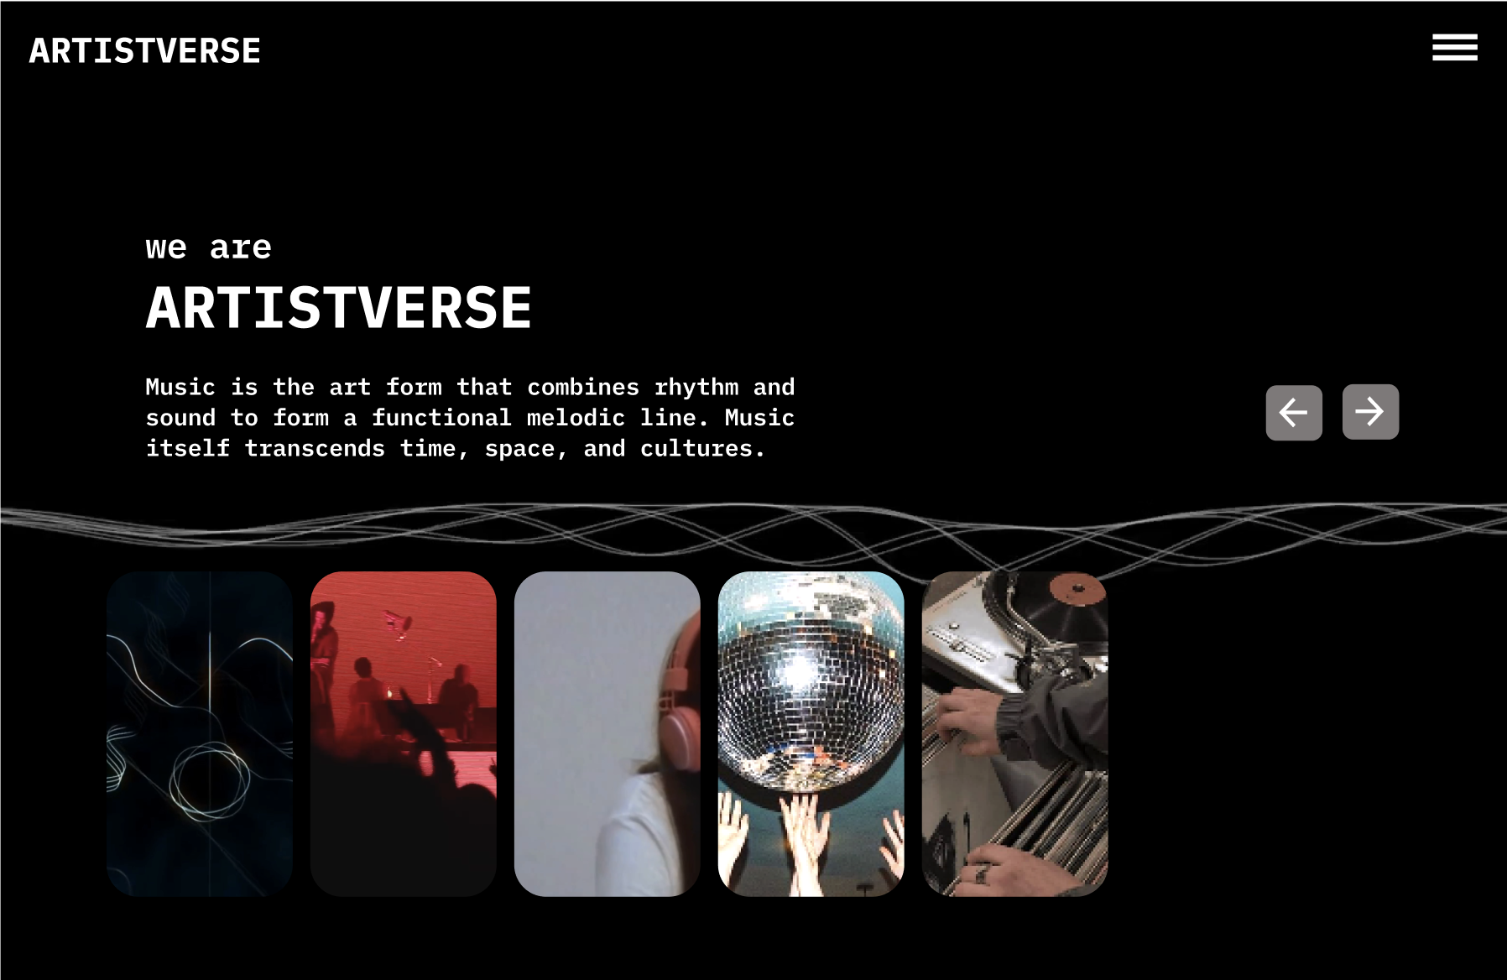
2. Click the "navbar-toggler-icon" button.
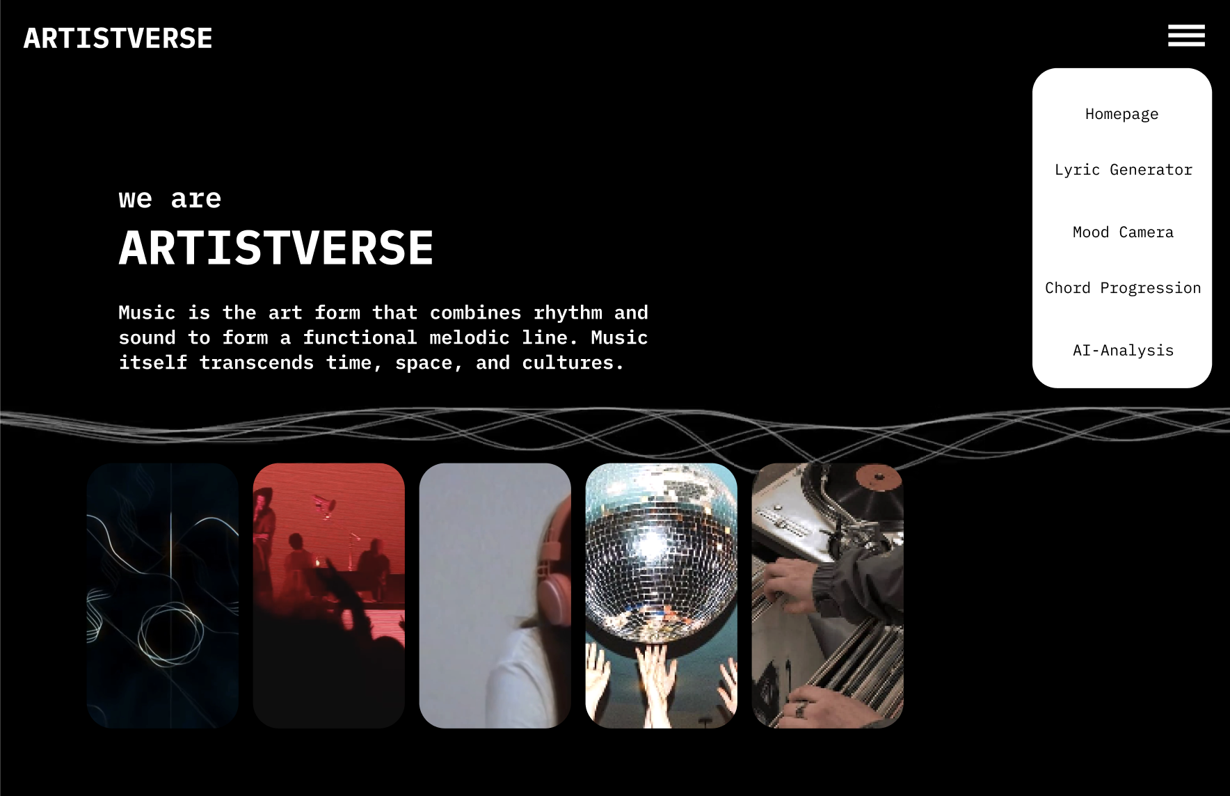
Document  Name | Artistverse-TestPlan V.3.0 | Owner | NS , WS | Page | 31
Document  Type | Test Plan | Release Date | 11/10/2024 | Print date | 11/10/2024

3. The system displays a drop-down menu with options: "Homepage", "Lyric
Generator", "Mood Camera", "Chord Progression", and "AI-Analysis".

4. Select "Lyric Generator" from the dropdown menu.

Document  Name | Artistverse-TestPlan V.3.0 | Owner | NS , WS | Page | 32
Document  Type | Test Plan | Release Date | 11/10/2024 | Print date | 11/10/2024

5. The system redirects to the Lyric Generator page.
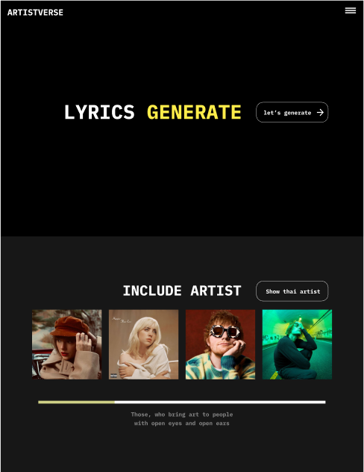
6. Click on the "Let's Generate" button.

Document  Name | Artistverse-TestPlan V.3.0 | Owner | NS , WS | Page | 33
Document  Type | Test Plan | Release Date | 11/10/2024 | Print date | 11/10/2024

7. The system displays options for composing lyrics: "Lyric Generator by Genre", "Lyric
Generator by Mood", and "Lyric Generator by Style Artist".
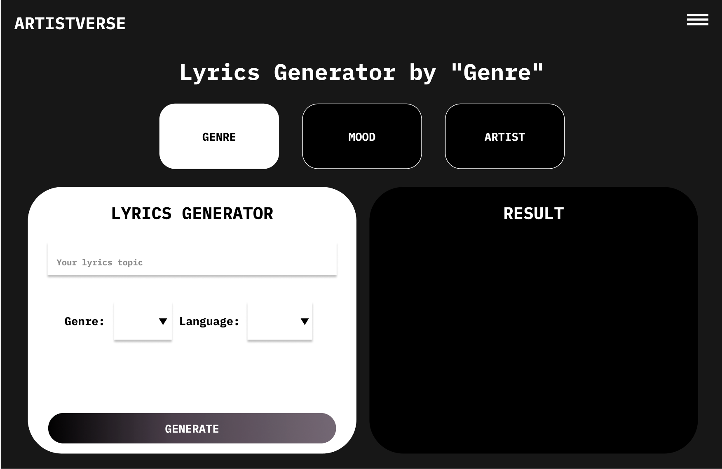
Document  Name | Artistverse-TestPlan V.3.0 | Owner | NS , WS | Page | 34
Document  Type | Test Plan | Release Date | 11/10/2024 | Print date | 11/10/2024

Test case:
No | Description | Input | Expected Result
1 | Verify Navbar  Toggler Icon Display | Open the website in a webbrowser. | The "navbar-toggler-icon"button is displayed in the  top right bar of every page.
2 | Verify Dropdown  Navbar Display | Click on the  "navbar-toggler-icon"  button. | A dropdown navbar is  displayed.
3 | Verify the  functionality of the  "navbar-toggler-icon"button. | Click the  "navbar-toggler-icon"  button. | The system displays a  drop-down menu with  options: "Homepage",  "Lyric Generator", "Mood  Camera", "Chord  Progression", and  "AI-Analysis".
4 | Verify navigation to  the Lyric Generator  page. | Select "Lyric Generator"from the drop-down  menu. | The system navigates to thelyrics generator page.
5 | Verify the presence ofthe "Let's Generate"  button. | Load the lyrics generatorpage | The "Let's Generate" buttonis displayed on the lyrics  generator page.
6 | Verify functionality ofthe "Let's Generate"  button. | Click the "Let's Generate"button on the lyrics  generator page. | The system displays optionsfor composing lyrics: "LyricGenerator by Genre", "LyricGenerator by Mood", and  "Lyric Generator by Style  Artist".

Document  Name | Artistverse-TestPlan V.3.0 | Owner | NS , WS | Page | 35
Document  Type | Test Plan | Release Date | 11/10/2024 | Print date | 11/10/2024

STC-02: View Artist Information
Description: This system verifies the process of generating lyrics based on a selectedgenre using the Lyric Generator feature.
Prepared Data: -
Test script:
1. Click the "Show Thai Artists" button.

Document  Name | Artistverse-TestPlan V.3.0 | Owner | NS , WS | Page | 36
Document  Type | Test Plan | Release Date | 11/10/2024 | Print date | 11/10/2024

2. Displays Thai artist information along with the "Show Non-Thai Artists" button.
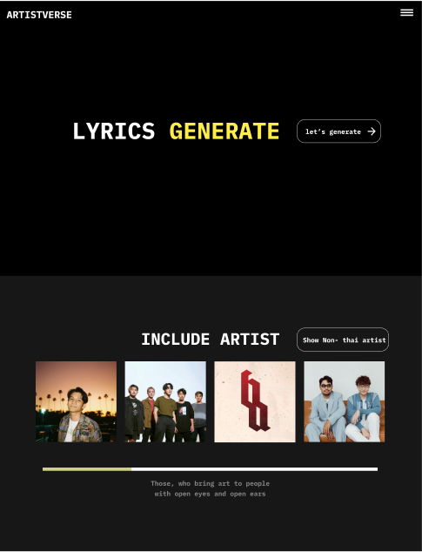
3. Displays a scroll bar to navigate through additional Thai artist information.4. Use the scroll bar to see additional Thai artist information.
5. Click the "Show Non-Thai Artists" button.
Document  Name | Artistverse-TestPlan V.3.0 | Owner | NS , WS | Page | 37
Document  Type | Test Plan | Release Date | 11/10/2024 | Print date | 11/10/2024

6. Displays the picture and name of the non-Thai artist along with the "Show Thai
Artists" button.

7. Displays a scroll bar to navigate through additional non-Thai artist information.8. Use the scroll bar to see additional non-Thai artist information.
Document  Name | Artistverse-TestPlan V.3.0 | Owner | NS , WS | Page | 38
Document  Type | Test Plan | Release Date | 11/10/2024 | Print date | 11/10/2024

Test case:
No | Description | Input | Expected Result
1 | Verify the display ofThai artist  information. | Click "Show Thai Artists"button. | System displays Thai artistinformation with a "Show  Non-Thai Artists" button.
2 | Verify the display ofthe scroll bar for Thaiartists. | Scroll through the Thai  artist list. | System provides a scroll barto navigate through  additional Thai artist  information.
3 | Verify the display ofnon-Thai artist  information. | Click "Show Non-Thai  Artists" button. | System displays non-Thai  artist information with a  "Show Thai Artists" button.
4 | Verify the display ofthe scroll bar for  non-Thai artists. | Scroll through the  non-Thai artist list. | System provides a scroll barto navigate through  additional non-Thai artist  information.
5 | Verify the switching  between Thai and  non-Thai artist  information. | Click "Show Thai Artists"button, then click "ShowNon-Thai Artists" button. | System correctly switchesbetween displaying Thai andnon-Thai artist information.

Document  Name | Artistverse-TestPlan V.3.0 | Owner | NS , WS | Page | 39
Document  Type | Test Plan | Release Date | 11/10/2024 | Print date | 11/10/2024

STC-03: Compose Lyrics by Genre
Description: This system verifies the process of generating lyrics based on a selectedgenre using the Lyric Generator feature.
Prepared Data: -
Test script:
9. The system displays Lyric Generator Page Options.

10. Select "Lyric Generator by Genre"

Document  Name | Artistverse-TestPlan V.3.0 | Owner | NS , WS | Page | 40
Document  Type | Test Plan | Release Date | 11/10/2024 | Print date | 11/10/2024

11. Fill in the required information in the form.
12. Click on the "GENERATE" button to start generating lyrics.
Test case:
No | Description | Input | Expected Result
1 | Provide information  in the form. | - Lyric topic: "My love"  - Genre: Select "pop"  from the dropdown  - Language: Select  "English" from the  dropdown | The generated lyrics are  displayed on the page basedon the provided inputs.
2 | Verify Error Handling(Missing Fields - AllEmpty) | - Lyric topic: ""  - Genre: ""  - Language: "" | The system displays an errormessage indicating the  missing fields  ("Please input a lyric topic.","Please select genre.",  "Please select a language.").
3 | Verify Error Handling(Missing Genre and  Language) | - Lyric topic: "My love"  - Genre: ""  - Language: "" | The system displays an errormessage indicating the  missing fields  ("Please select genre.",  "Please select a language.").
4 | Verify Error Handling(Missing Genre) | - Lyric topic: "My love"  - Genre: ""  - Language: Select  "English" from the  dropdown | The system displays an errormessage indicating the  missing fields  ("Please select genre.”).
4 | Verify Error Handling(Missing Language) | - Lyric topic: "My love"  - Genre: Select "pop"  from the dropdown  - Language: "" | The system displays an errormessage indicating the  missing fields  ("Please select a  language.").
5 | Verify Error Handling(Missing Lyric topic) | - Lyric topic: ""  - Genre: Select "pop"  from the dropdown  - Language: Select  "English" from the  dropdown | The system displays an errormessage indicating the  missing fields  ("Please input a lyric  topic.").
6 | Verify Error Handling | Disconnect the internet | The system displays an error

Document  Name | Artistverse-TestPlan V.3.0 | Owner | NS , WS | Page | 41
Document  Type | Test Plan | Release Date | 11/10/2024 | Print date | 11/10/2024

 | (No Internet  Connection) | and click the "generate"  button. | message  "Unable to compose lyrics."

Document  Name | Artistverse-TestPlan V.3.0 | Owner | NS , WS | Page | 42
Document  Type | Test Plan | Release Date | 11/10/2024 | Print date | 11/10/2024

STC-04: Compose Lyrics by Mood
Description: This system verifies the process of generating lyrics based on a selectedmood using the Lyric Generator feature.
Prepared Data:
Test script:
1. The system displays Lyric Generator Page Options.

2. Select "Lyric Generator by Mood"
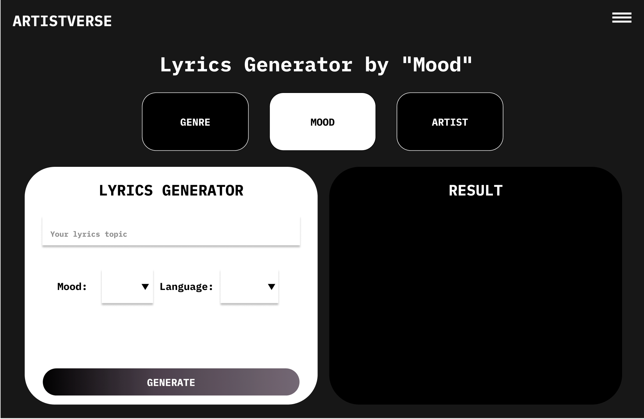
Document  Name | Artistverse-TestPlan V.3.0 | Owner | NS , WS | Page | 43
Document  Type | Test Plan | Release Date | 11/10/2024 | Print date | 11/10/2024

13. Fill in the required information in the form.
14. Click on the "GENERATE" button to start generating lyrics.
Test case:
No | Description | Input | Expected Result
1 | Provide information  in the form. | - Lyric topic: "My love"  - Mood: Select  "Romantic" from the  dropdown  - Language: Select  "English" from the  dropdown | The generated lyrics are  displayed on the page basedon the provided inputs.
2 | Verify Error Handling(Missing Fields - AllEmpty) | - Lyric topic: ""  - Mood: ""  - Language: "" | The system displays an errormessage indicating the  missing fields  ("Please input a lyric topic.","Please select mood.",  "Please select a language.").
3 | Verify Error Handling(Missing mood and  Language) | - Lyric topic: "My love"  - Mood: ""  - Language: "" | The system displays an errormessage indicating the  missing fields  ("Please select mood.",  "Please select a language.").
4 | Verify Error Handling(Missing Mood) | - Lyric topic: "My love"  - Mood: ""  - Language: Select  "English" from the  dropdown | The system displays an errormessage indicating the  missing fields  ("Please select mood.”).
4 | Verify Error Handling(Missing Language) | - Lyric topic: "My love"  - Mood: Select  "Romantic" from the  dropdown  - Language: "" | The system displays an errormessage indicating the  missing fields  ("Please select a  language.").
5 | Verify Error Handling(Missing Lyric topic) | - Lyric topic: ""  - Mood: Select  "Romantic" from the  dropdown  - Language: Select  "English" from the  dropdown | The system displays an errormessage indicating the  missing fields  ("Please input a lyric  topic.").

Document  Name | Artistverse-TestPlan V.3.0 | Owner | NS , WS | Page | 44
Document  Type | Test Plan | Release Date | 11/10/2024 | Print date | 11/10/2024

6 | Verify Error Handling(No Internet  Connection) | Disconnect the internet  and click the "generate"  button. | The system displays an errormessage  "Unable to compose lyrics."

Document  Name | Artistverse-TestPlan V.3.0 | Owner | NS , WS | Page | 45
Document  Type | Test Plan | Release Date | 11/10/2024 | Print date | 11/10/2024

STC-05: Compose Lyrics by Style Artist
Description: This system verifies the process of generating lyrics based on a selectedartist using the Lyric Generator feature.
Prepared Data:
Test script:
1. The system displays Lyric Generator Page Options.

2. Select "Lyric Generator by Style Artist"
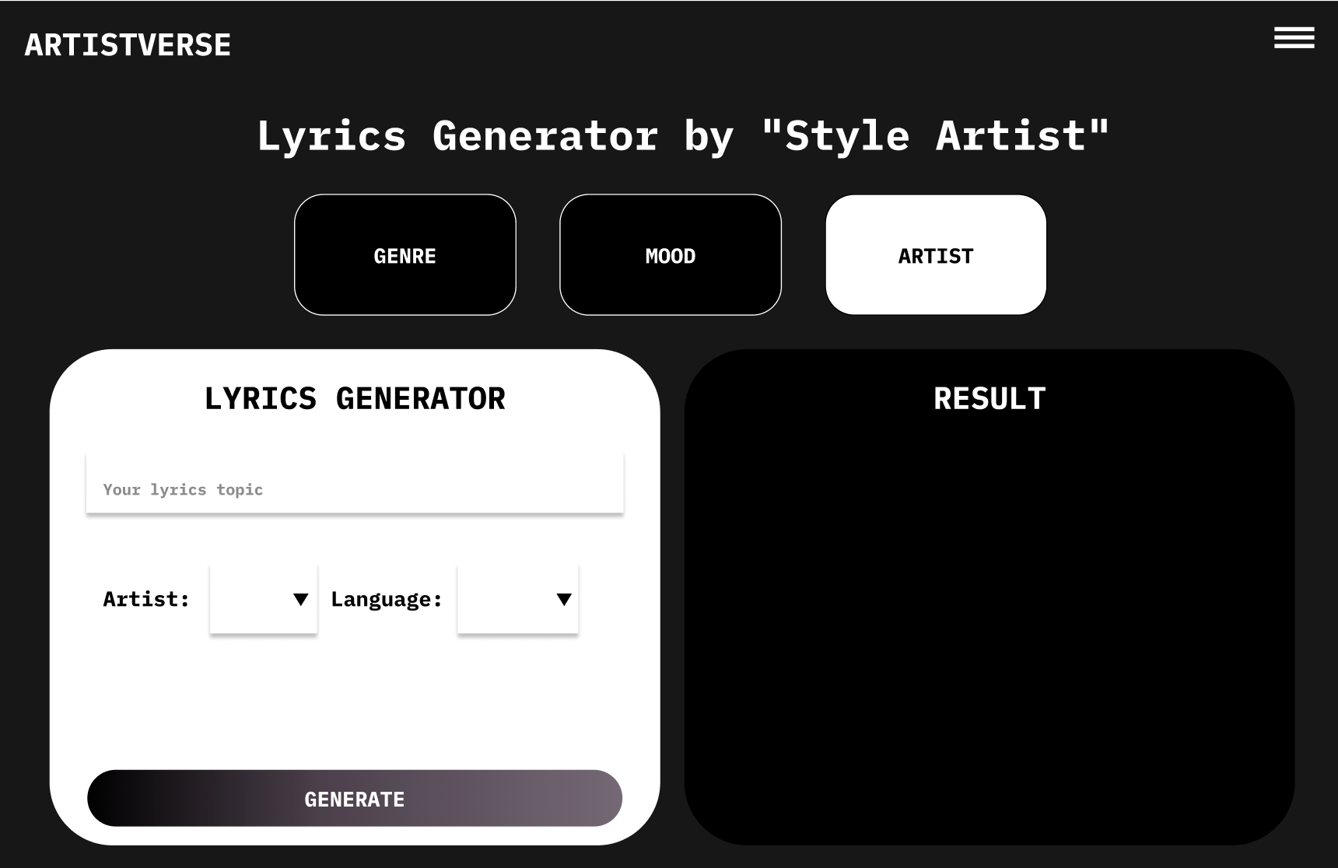
Document  Name | Artistverse-TestPlan V.3.0 | Owner | NS , WS | Page | 46
Document  Type | Test Plan | Release Date | 11/10/2024 | Print date | 11/10/2024

3. Fill in the required information in the form.
4. Click on the "GENERATE" button to start generating lyrics.
Test case:
No | Description | Input | Expected Result
1 | Provide information  in the form. | - Lyric topic: "My love"  - Artist: Select "Taylor  Swift" from the dropdown- Language: Select  "English" from the  dropdown | The generated lyrics are  displayed on the page basedon the provided inputs.
2 | Verify Error Handling(Missing Fields - AllEmpty) | - Lyric topic: ""  - Artist: ""  - Language: "" | The system displays an errormessage indicating the  missing fields  ("Please input a lyric topic.","Please select artist.",  "Please select a language.").
3 | Verify Error Handling(Missing artist and  Language) | - Lyric topic: "My love"  - Artist: ""  - Language: "" | The system displays an errormessage indicating the  missing fields  ("Please select artist.",  "Please select a language.").
4 | Verify Error Handling(Missing Artist) | - Lyric topic: "My love"  - Artist: ""  - Language: Select  "English" from the  dropdown | The system displays an errormessage indicating the  missing fields  ("Please select artist.”).
4 | Verify Error Handling(Missing Language) | - Lyric topic: "My love"  - Mood: Select  "Romantic" from the  dropdown  - Language: "" | The system displays an errormessage indicating the  missing fields  ("Please select a  language.").
5 | Verify Error Handling(Missing Lyric topic) | - Lyric topic: ""  - Artist: Select "Taylor  Swift" from the dropdown- Language: Select  "English" from the  dropdown | The system displays an errormessage indicating the  missing fields  ("Please input a lyric  topic.").
6 | Verify Error Handling | Disconnect the internet | The system displays an error

Document  Name | Artistverse-TestPlan V.3.0 | Owner | NS , WS | Page | 47
Document  Type | Test Plan | Release Date | 11/10/2024 | Print date | 11/10/2024

 | (No Internet  Connection) | and click the "generate"  button. | message  "Unable to compose lyrics."

Document  Name | Artistverse-TestPlan V.3.0 | Owner | NS , WS | Page | 48
Document  Type | Test Plan | Release Date | 11/10/2024 | Print date | 11/10/2024

STC-06: Save lyrics
Description: This system verifies the functionality of saving lyrics to the songwriter'slocal computer.
Prepared Data:
Test script:
1.The system displays the generated lyrics to the songwriter.
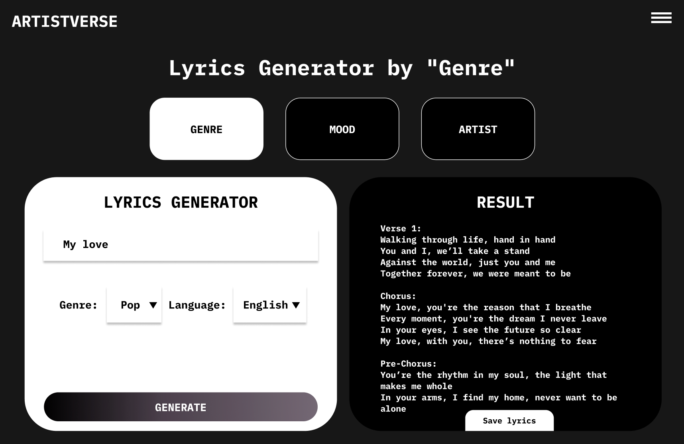
2. Click on the "Save" button
Test case:
No | Description | Input | Expected Result
1 | Click the "Save"  button | Click on the "Save" button | The system starts the  process of saving the lyricsto the composer's computerin a.txt file format.
2 | Handle no internet  connection | Disconnect the internet  and attempt to save | The system displays an errormessage "Unable to save  lyrics".

Document  Name | Artistverse-TestPlan V.3.0 | Owner | NS , WS | Page | 49
Document  Type | Test Plan | Release Date | 11/10/2024 | Print date | 11/10/2024

STC-07: Songwriter can capture facial expressions to detect mood and receiverecommended song
Description: The system testing for songwriter can capture facial expressions todetect mood and receive a recommended song.
Prepared Data:
●  ● | The songwriter has granted permission for camera access.  ●  Test data in Appendix A
Test script:
1. Click "Camera Mood" page.
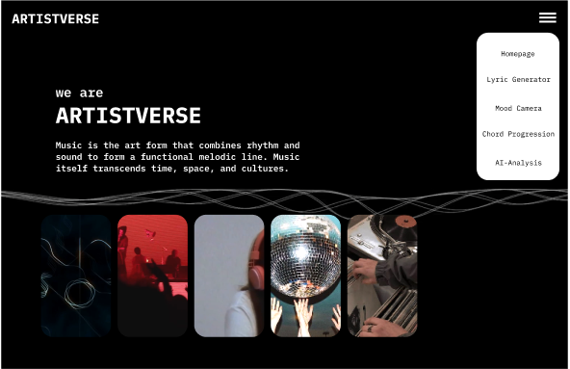
Document  Name | Artistverse-TestPlan V.3.0 | Owner | NS , WS | Page | 50
Document  Type | Test Plan | Release Date | 11/10/2024 | Print date | 11/10/2024

2. System redirects to the Camera Mood page.
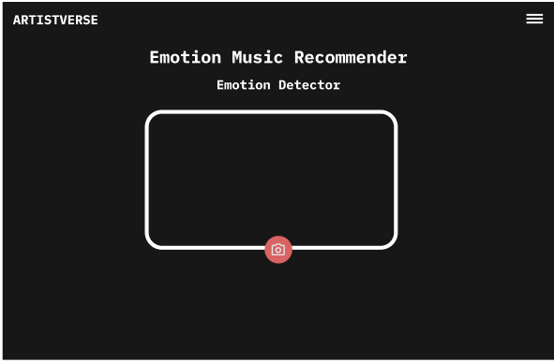
3. Click the "Capture" button.
4. System receives the facial expression of the songwriter.
5. The system analyzes the facial expression to determine the songwriter's mood.6. The system displays the detected mood
(Happy,Sad,Neutral,Angry,Fearful,Surprised).
7. The system requests a song from the specific mood playlist on Spotify using
Spotify API.
8. The system displays the recommended songs with a "Listen on Spotify"
button.
Test case:
No | Description | Input | Expected Result
1 | Songwriter clicks  "Capture" button | Click "Capture"  button | System displays thecamera view and  provides capture  button
2 | System receives  facial expression | Facial expression  image | System analyzes  facial expression todetermine mood
3 | Unable to detect  mood | Unclear facial  expression image | System displays  "Mood could not bedetected, Try again"

Document  Name | Artistverse-TestPlan V.3.0 | Owner | NS , WS | Page | 51
Document  Type | Test Plan | Release Date | 11/10/2024 | Print date | 11/10/2024

4 | Detects mood and  recommends song | Clear facial  expression image | System displays  detected mood and  recommended songs
5 | Songwriter clicks  "reset" button to  capture again | Click "reset" button | System clears all  input and returns tocamera view
6 | Songwriter denies  camera access | Deny camera access | System ends with  failure message

Document  Name | Artistverse-TestPlan V.3.0 | Owner | NS , WS | Page | 52
Document  Type | Test Plan | Release Date | 11/10/2024 | Print date | 11/10/2024

STC-08: Songwriter can select song from recommended playlist to listen on Spotify
Description: The system testing for songwriter can select a song from therecommended playlist to listen on the Spotify platform.
Prepared Data:
●  ● | Songwriter has completely detected the mood and recommended the song.  ●  Test data Appendix A
Test script:
1. Songwriter selects a song by clicking the "Listen on Spotify" button in the
recommended songs on the playlist.
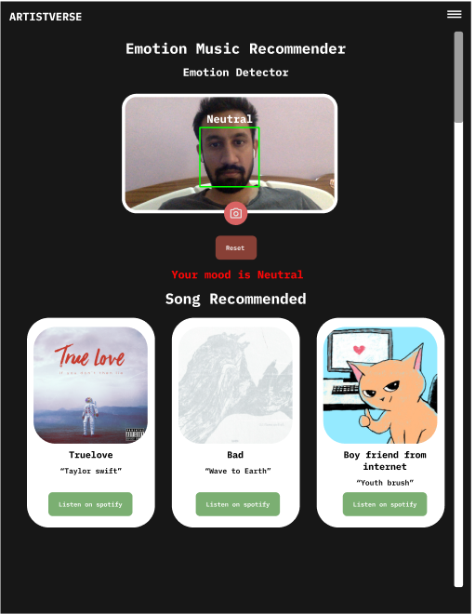
2. The system retrieves the Spotify link of the selected song from the database.3. The system redirects the songwriter to the Spotify interface using the Spotify
link.
Test case:
No | Description | Input | Expected Result

Document  Name | Artistverse-TestPlan V.3.0 | Owner | NS , WS | Page | 53
Document  Type | Test Plan | Release Date | 11/10/2024 | Print date | 11/10/2024

1 | Songwriter selects arecommended song | Click "Listen on  Spotify" button | System redirects  songwriter to  Spotify interface  with the song
2 | System retrieves  Spotify link from  database | Selected song | System successfullyredirects to Spotify  interface
3 | Songwriter has  internet connection | Internet access | System displays  error message aboutinternet connectivity
4 | Songwriter does nothave internet  connection | No internet access | System displays  error message aboutinternet connectivity

Document  Name | Artistverse-TestPlan V.3.0 | Owner | NS , WS | Page | 54
Document  Type | Test Plan | Release Date | 11/10/2024 | Print date | 11/10/2024

4.2 Progress II
STC-09: Access "Chord Progression" Page
Description: This test case verifies that the songwriter can access the "ChordProgression" page from the navigation menu.
Prepared Data: None
Test script:
1. Open the Artistverse website in a web browser.

2. Click the "navbar-toggler-icon" button.

Document  Name | Artistverse-TestPlan V.3.0 | Owner | NS , WS | Page | 55
Document  Type | Test Plan | Release Date | 11/10/2024 | Print date | 11/10/2024

3. The system displays a drop-down menu with options: "Homepage", "Lyric
Generator", "Mood Camera", "Chord Progression", and "AI-Analysis".

4. Select "Chord progression" from the dropdown menu.
5. The system displays the Chord Progression page.
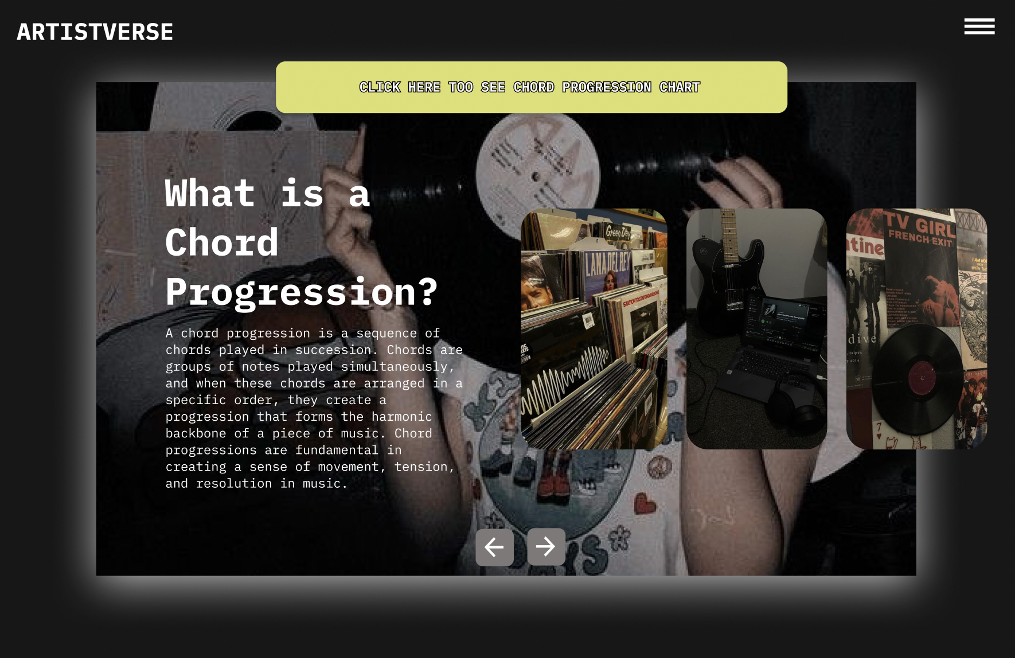
Document  Name | Artistverse-TestPlan V.3.0 | Owner | NS , WS | Page | 56
Document  Type | Test Plan | Release Date | 11/10/2024 | Print date | 11/10/2024

Test case:
No | Description | Input | Expected Result
1 | Verify Navbar Toggler IconDisplay | Open the website in a  web browser. | The  "navbar-toggler-icon"  button is displayed in thetop right bar of every  page.
2 | Verify Dropdown Navbar  Display | Click on the  "navbar-toggler-icon"  button. | A dropdown navbar is  displayed.
3 | Verify the functionality of  the "navbar-toggler-icon"  button. | Click the  "navbar-toggler-icon"  button. | The system displays a  drop-down menu with  options: "Homepage",  "Lyric Generator",  "Mood Camera", "ChordProgression", and  "AI-Analysis".
4 | Verify navigation to the  Chord Progression page. | Select "Chord  Progression" from thedrop-down menu. | The system navigates tothe Chord Progression  page.

Document  Name | Artistverse-TestPlan V.3.0 | Owner | NS , WS | Page | 57
Document  Type | Test Plan | Release Date | 11/10/2024 | Print date | 11/10/2024

STC-10: Navigate Between Chord Progressions
Description: This test case verifies that the songwriter can navigate between differentchord progressions using the "Next" and "Back" buttons.
Prepared Data: None
Test script:
1. The system displays the main page.

2. Click the "Next" button to view the next chord progression.
3. The system displays the next chord progression.
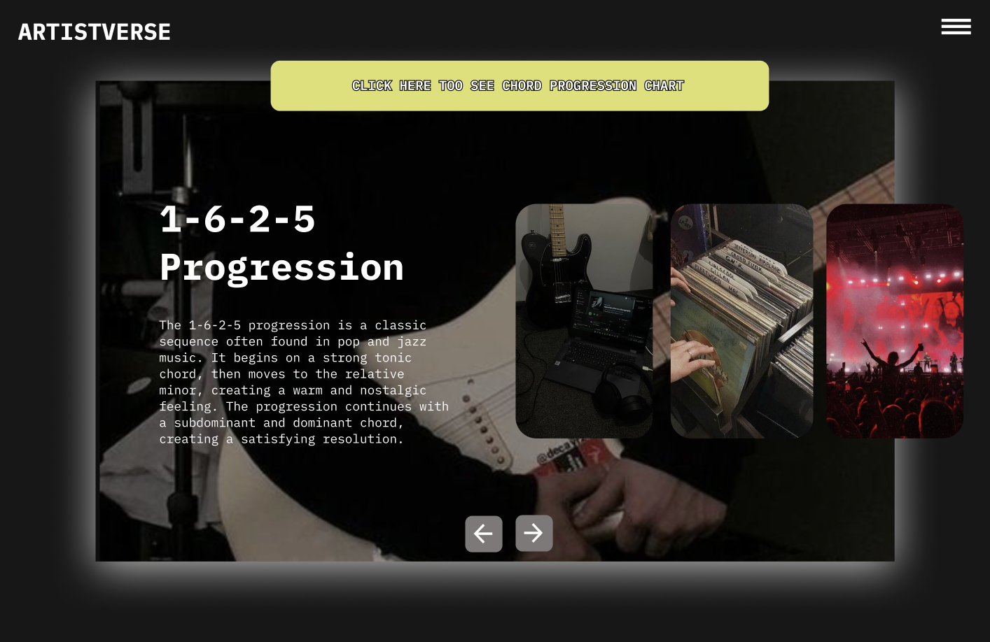
Document  Name | Artistverse-TestPlan V.3.0 | Owner | NS , WS | Page | 58
Document  Type | Test Plan | Release Date | 11/10/2024 | Print date | 11/10/2024

4. Click the "Back" button to return to the previous chord progression or the
main page.
5. The system displays the previous chord progression or returns to the main
page.

Document  Name | Artistverse-TestPlan V.3.0 | Owner | NS , WS | Page | 59
Document  Type | Test Plan | Release Date | 11/10/2024 | Print date | 11/10/2024

Test case:
No | Description | Input | Expected Result
1 | Verify that the system  displays the main "Chord  Progression" page. | Access the "Chord  Progression" page. | The main "Chord  Progression" page withintroductory informationis displayed.
2 | Verify that clicking the  "Next" button displays the  next chord progression. | Click the "Next" buttonon the chord  progression page. | The system displays thenext chord progression.
3 | Verify that the system  displays detailed informationabout the next chord  progression. | - | The system displaysdetailed informationabout the next chordprogression.
4 | Verify that clicking the  "Back" button returns to theprevious chord progressionor the main page. | Click the "Back" buttonon the chord  progression page. | The system displays theprevious chord  progression or returns tothe main page.
5 | Verify that the system  displays the previous chordprogression or returns to themain page. | - | The system displays theprevious chord  progression or the main"Chord Progression"  page.

Document  Name | Artistverse-TestPlan V.3.0 | Owner | NS , WS | Page | 60
Document  Type | Test Plan | Release Date | 11/10/2024 | Print date | 11/10/2024

STC-11: View Chord Progression Chart
Description: This test case verifies that the songwriter can view the chordprogression chart after accessing the "Chord Progression" page.
Prepared Data: None
Test script:
1. The system displays the "CLICK HERE TO SEE CHORD PROGRESSION
CHART" button.

2. Click the "CLICK HERE TO SEE CHORD PROGRESSION CHART"
button.
3. The system displays a chart showing various chord progressions and keys.
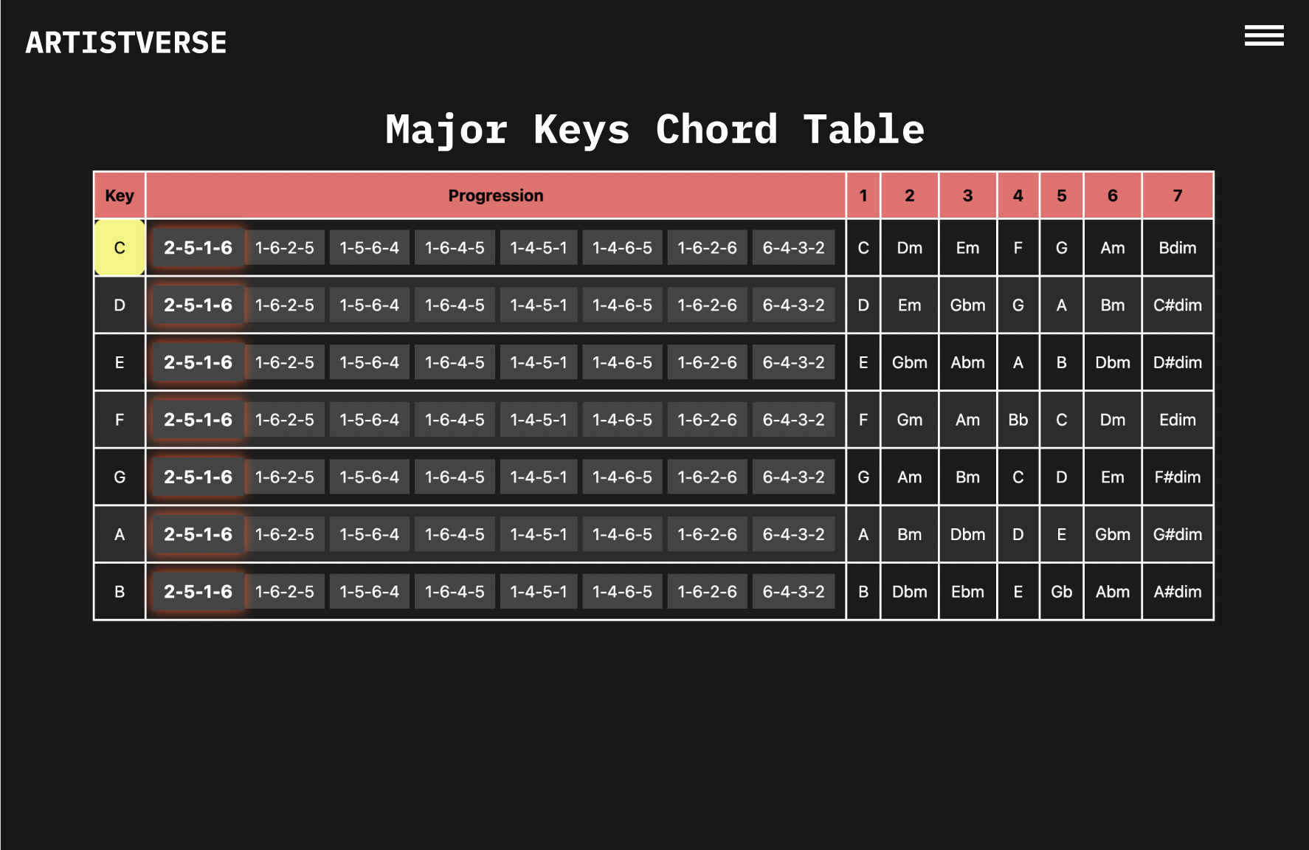
Document  Name | Artistverse-TestPlan V.3.0 | Owner | NS , WS | Page | 61
Document  Type | Test Plan | Release Date | 11/10/2024 | Print date | 11/10/2024

Test case:
No | Description | Input | Expected Result
1 | Verify the system displays  the "CLICK HERE TO SEECHORD PROGRESSIONCHART" button. | Access the "Chord  Progression" page. | The "CLICK HERE TOSEE CHORD  PROGRESSION  CHART" button is  visible.
2 | Click the "CLICK HERE  TO SEE CHORD  PROGRESSION CHART"button. | Click the "CLICK  HERE TO SEE  CHORD  PROGRESSION  CHART" button. | The system displays a  chart showing various  chord progressions andkeys.

Document  Name | Artistverse-TestPlan V.3.0 | Owner | NS , WS | Page | 62
Document  Type | Test Plan | Release Date | 11/10/2024 | Print date | 11/10/2024

STC-12: Interact with Chord Progression Chart
Description: This test case verifies that the songwriter can select and highlight achord progression from the chart and view corresponding guitar chord diagrams.
Prepared Data: None
Test script:
1. Select a chord progression from the table (2-5-1-6, 1-6-2-5, 1-5-6-4, 1-6-4-5,
1-4-5-1,1-4-6-5, 1-6-2-6, 6-4-3-2).
2. The system highlights the selected progression and key in yellow.
3. The system displays a series of guitar chord diagrams corresponding to the
selected progression below the chart.
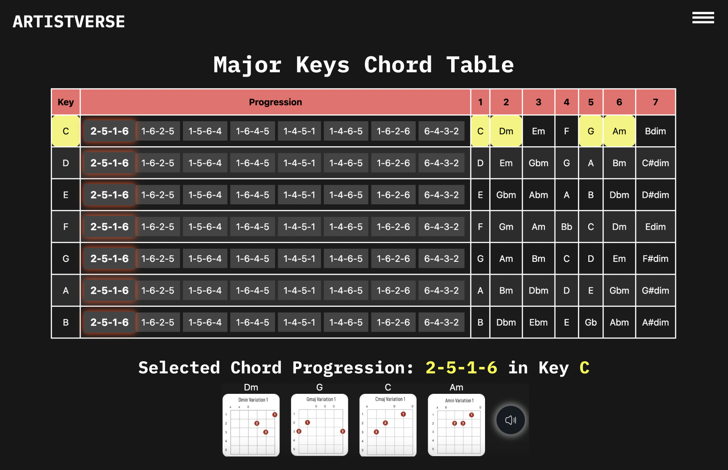
Test case:
No | Description | Input | Expected Result
1 | Select a chord progression  from the table. | Select a progression  (2-5-1-6 in C major). | The selected progressionand key are highlightedin yellow.
2 | Verify the system displays  guitar chord diagrams. | Select a progression. | The system displays  guitar chord diagrams  corresponding to the  selected progression.

Document  Name | Artistverse-TestPlan V.3.0 | Owner | NS , WS | Page | 63
Document  Type | Test Plan | Release Date | 11/10/2024 | Print date | 11/10/2024

STC-13: Listen to Piano Audio Playback
Description: This test case verifies that the songwriter can listen to the piano audioplayback of the selected chord progression.
Prepared Data: None
Test script:
1. Click the "sound" button to listen to the piano audio playback of the selected
chord progression.

2. The system highlights the chord in the progression with an orange color as it is
played.
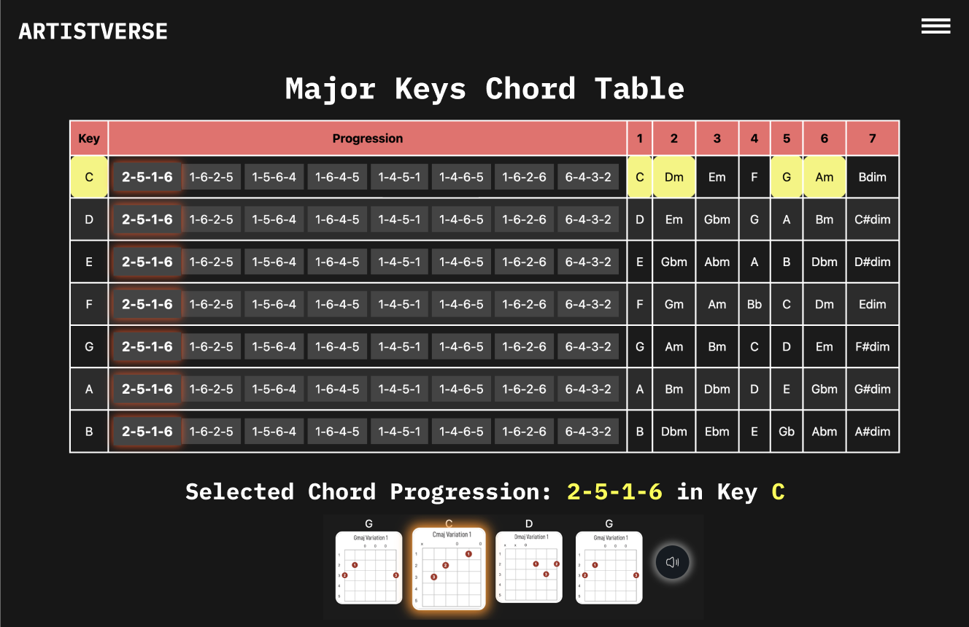
Document  Name | Artistverse-TestPlan V.3.0 | Owner | NS , WS | Page | 64
Document  Type | Test Plan | Release Date | 11/10/2024 | Print date | 11/10/2024

3. As the audio playback progresses, the system moves the highlight to the next
chord.
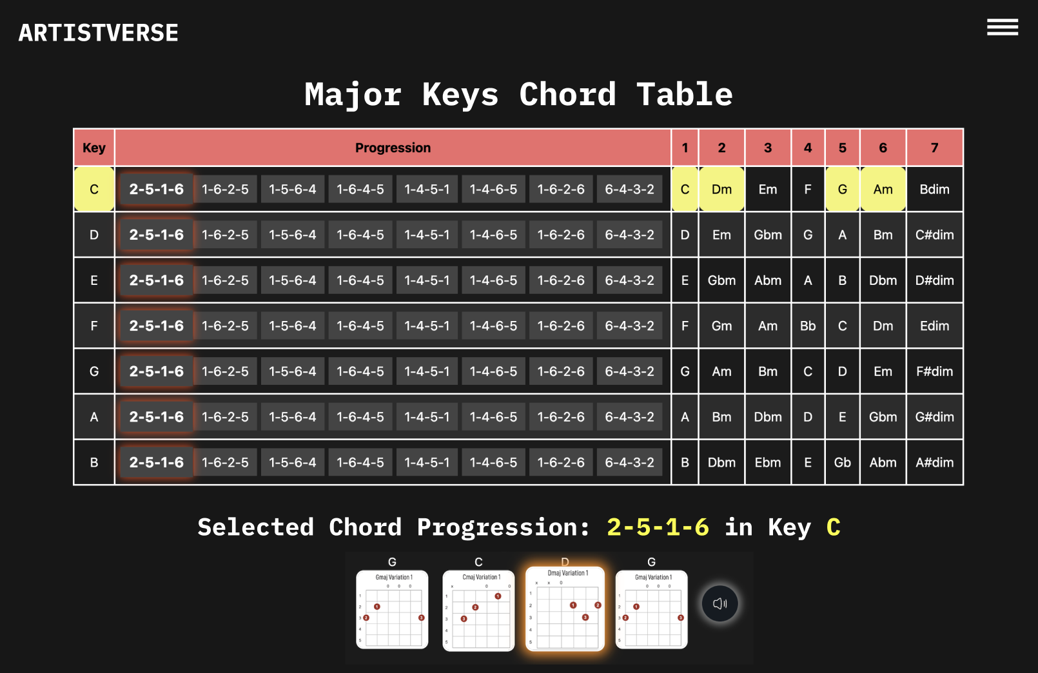
4. The system stops highlighting chords when the audio playback finishes.
Test case:
No | Description | Input | Expected Result
1 | Verify that clicking the  "sound" button starts playingthe chord progression audio. | Click the "sound"  button. | The audio playback of  the selected chord  progression starts.
2 | Verify that the system  highlights the chord  currently being played  during the audio playback. | Observe the highlightsduring playback. | The system highlights  the chord in the  progression with an  orange color as it is  played.
3 | Verify that the system  highlights the next chord asthe playback progresses. | Observe the  progression during  playback. | As the audio playbackprogresses, the systemmoves the highlight tothe next chord.
4 | Verify that the system stopshighlighting the chords  when the playback finishes. | Wait for the playback  to finish. | The system stops  highlighting chords  when the audio playbackfinishes.

Document  Name | Artistverse-TestPlan V.3.0 | Owner | NS , WS | Page | 65
Document  Type | Test Plan | Release Date | 11/10/2024 | Print date | 11/10/2024

STC-14: Access AI Analysis Page
Description: This system verifies that the navbar and navigate to Ai-Analysis pagecorrectly
Prepared Data: None
Test script:
1. Open the Artistverse website in a web browser.

2. Click the "navbar-toggler-icon" button.

Document  Name | Artistverse-TestPlan V.3.0 | Owner | NS , WS | Page | 66
Document  Type | Test Plan | Release Date | 11/10/2024 | Print date | 11/10/2024

3. The system displays a drop-down menu with options: "Homepage", "Lyric
Generator", "Mood Camera", "Chord Progression", and "AI-Analysis".

1. Select "AI-Analysis" from the dropdown menu.

2. The system display AI-Analysis page
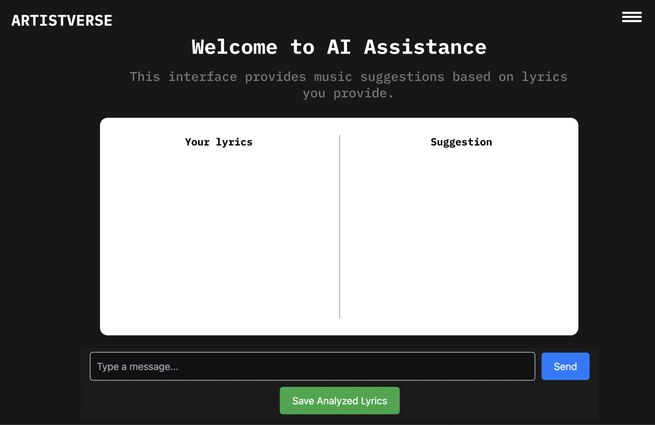
Document  Name | Artistverse-TestPlan V.3.0 | Owner | NS , WS | Page | 67
Document  Type | Test Plan | Release Date | 11/10/2024 | Print date | 11/10/2024

Test case:
No | Description | Input | Expected Result
1 | Verify Navbar Toggler  Icon Display | Open the website ina web browser. | The "navbar-toggler-icon"button is displayed in thetop right bar of every  page.
2 | Verify Dropdown NavbarDisplay | Click on the  "navbar-toggler-icon" button. | A dropdown navbar is  displayed.
3 | Verify the functionality ofthe "navbar-toggler-icon"button. | Click the  "navbar-toggler-icon" button. | The system displays a  drop-down menu with  options: "Homepage",  "Lyric Generator", "MoodCamera", "Chord  Progression", and  "AI-Analysis".
4 | Verify navigation to the  AI-Analysis page. | Select "AI-Analysis"from the drop-downmenu. | The system navigates tothe Ai-Analysis page.

Document  Name | Artistverse-TestPlan V.3.0 | Owner | NS , WS | Page | 68
Document  Type | Test Plan | Release Date | 11/10/2024 | Print date | 11/10/2024

STC-15: Input Lyrics and Analyze
Description: This test verifies that the songwriter can input lyrics, analyze them, anddisplay the results correctly.
Prepared Data: Sample lyrics for input.
Test script:
1. Input lyrics into the text field.
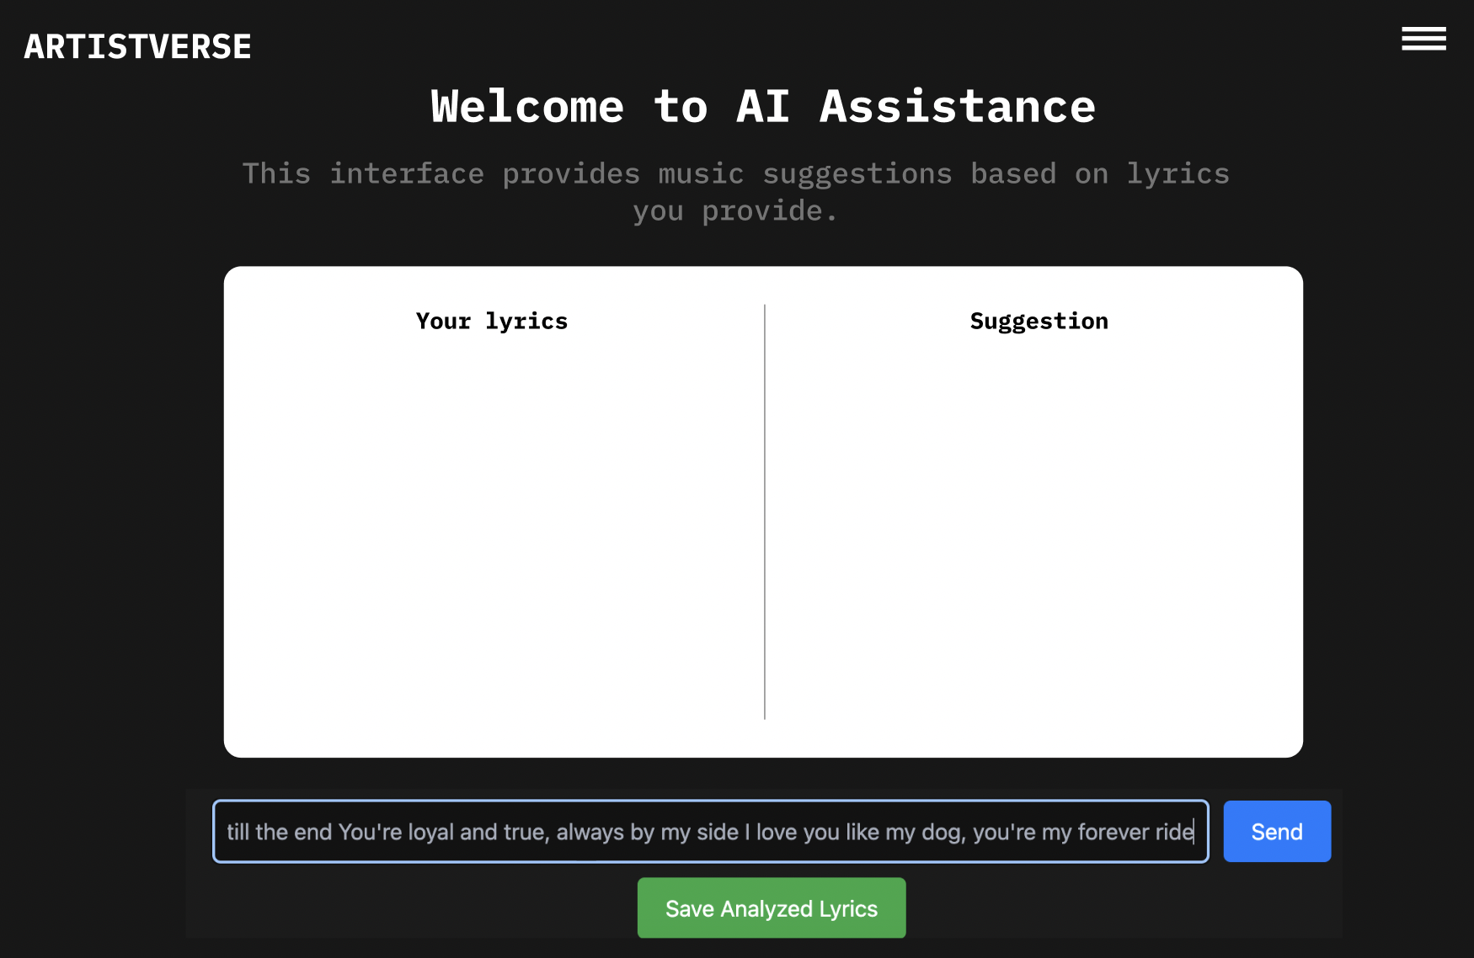
2. Click "Send" to analyze the lyrics.
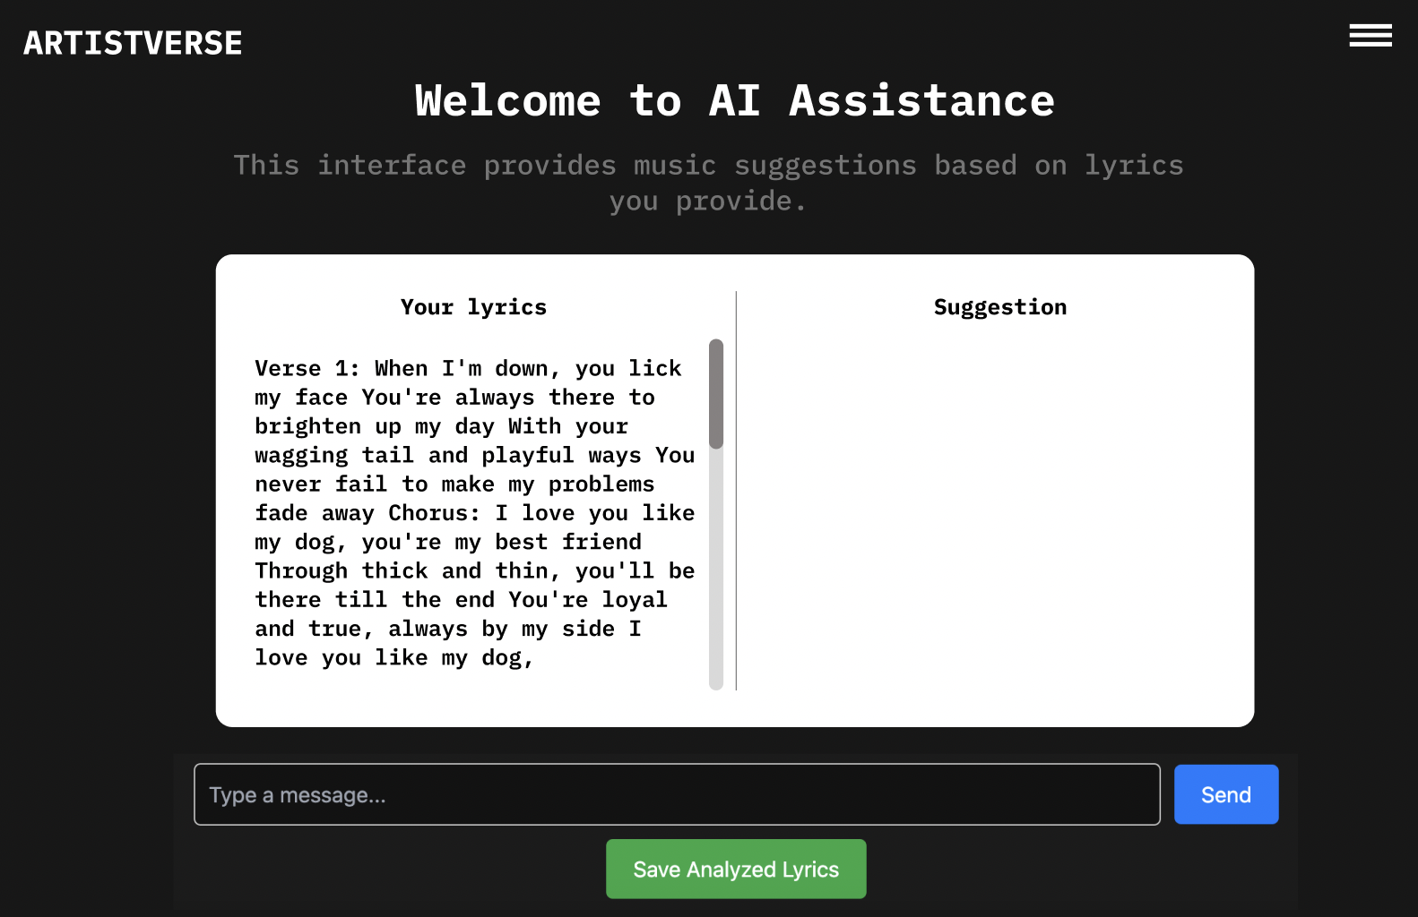
Document  Name | Artistverse-TestPlan V.3.0 | Owner | NS , WS | Page | 69
Document  Type | Test Plan | Release Date | 11/10/2024 | Print date | 11/10/2024

3. Verify the system displays analysis results.
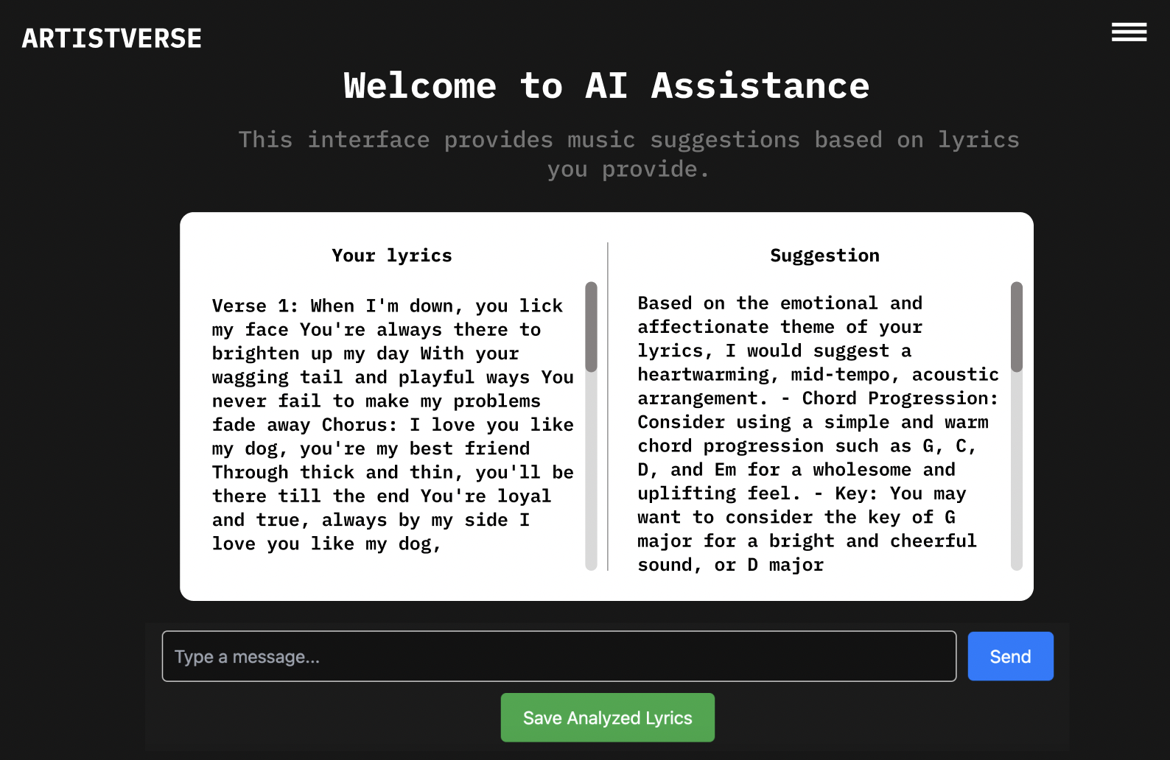
Test case:
No | Description | Input | Expected Result
1 | Input valid lyrics  and analyze | [Verse 1] When youwere here before  Couldn't look you inthe eye You're just  like an angel Your  skin makes me cry  You float like a  feather In a beautifulworld I wish I was  special You're so  fuckin' special  [Chorus] But I'm a  creep, I'm a weirdoWhat the hell am I  doin' here? I don't  belong here [Verse  2] I don't care if it  hurts I wanna have  control I want a  perfect body I wanta perfect soul I wantyou to notice WhenI'm not around  You're so fuckin'  special I wish I wasspecial [Chorus] But | "analysis": "Your  lyrics suggest a  sense of longing andan introspective,  melancholic mood.Here's a suggestionfor a musical  interpretation:\n\n-  Chords: The song  could be  accompanied by  simple, arpeggiatedchords, such as G,  B, C, and Cm, to  capture the  emotional depth of  the lyrics.\n\n- Key:The song could be inthe key of G major,providing a  melancholic yet  hopeful feel.\n\n-  Time Signature: Thelyrics lend  themselves well to a4/4 time signature,

Document  Name | Artistverse-TestPlan V.3.0 | Owner | NS , WS | Page | 70
Document  Type | Test Plan | Release Date | 11/10/2024 | Print date | 11/10/2024

 |  | I'm a creep, I'm a  weirdo What the hellam I doin' here? I  don't belong here  Oh-oh, oh-oh | allowing for a  comfortable and  natural flow of the  melody.\n\n- Tempo:A slow tempo,  around 60-70 beatsper minute, would  enhance the  emotional impact ofthe lyrics and the  contemplative natureof the song.\n\n-  Musical  Information: The  verses could featurea minimalistic,  gentle guitar  arpeggio  accompanied by a  melancholic vocal  melody. The chorusmight build with a  slightly fuller  arrangement, addinggentle percussion  and additional  instrumentation to  convey the  emotional intensity.Overall, the music  should capture the  vulnerability and  longing expressed inthe lyrics."

Document  Name | Artistverse-TestPlan V.3.0 | Owner | NS , WS | Page | 71
Document  Type | Test Plan | Release Date | 11/10/2024 | Print date | 11/10/2024

STC-16: Handle Empty Lyrics Input
Description: This test verifies that the system correctly handles empty lyrics input bydisplaying an error message.
Prepared Data: None
Test script:
1. Leave the lyrics input field empty.

2. Click "Send" to trigger analysis.
3. Verify the system displays an error message.
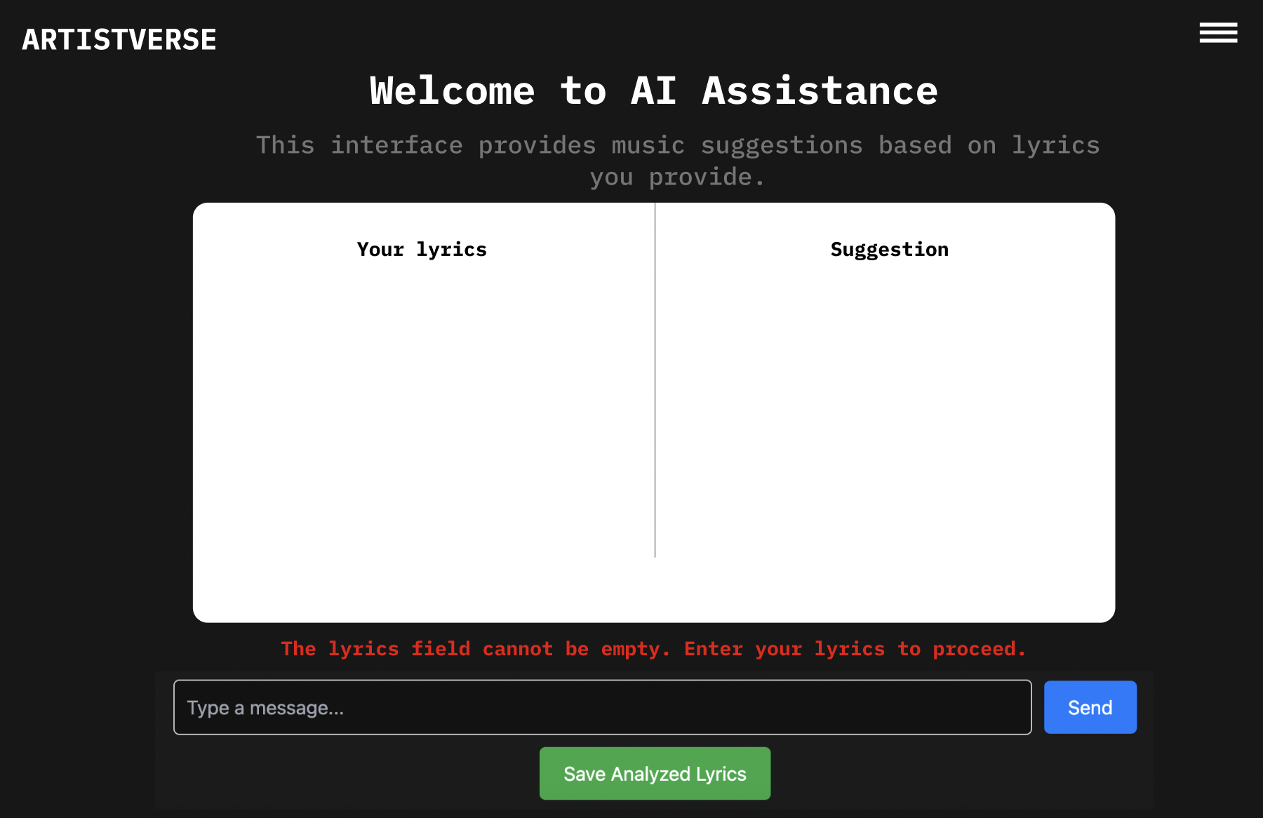
Document  Name | Artistverse-TestPlan V.3.0 | Owner | NS , WS | Page | 72
Document  Type | Test Plan | Release Date | 11/10/2024 | Print date | 11/10/2024

Test case:
No | Description | Input | Expected Result
1 | Attempt to analyze  without input lyrics | “” | Error message: "Thelyrics field cannot beempty. Enter your  lyrics to proceed."

Document  Name | Artistverse-TestPlan V.3.0 | Owner | NS , WS | Page | 73
Document  Type | Test Plan | Release Date | 11/10/2024 | Print date | 11/10/2024

STC-17: Save Analyzed Lyrics to Local File
Description: This test verifies that the analyzed lyrics can be saved to the localcomputer
Prepared Data: Analyzed lyrics available.
Test script:
1. Perform lyrics analysis.

2. Click "Save" to save the analyzed lyrics.
3. Verify the lyrics are saved as a .txt file.
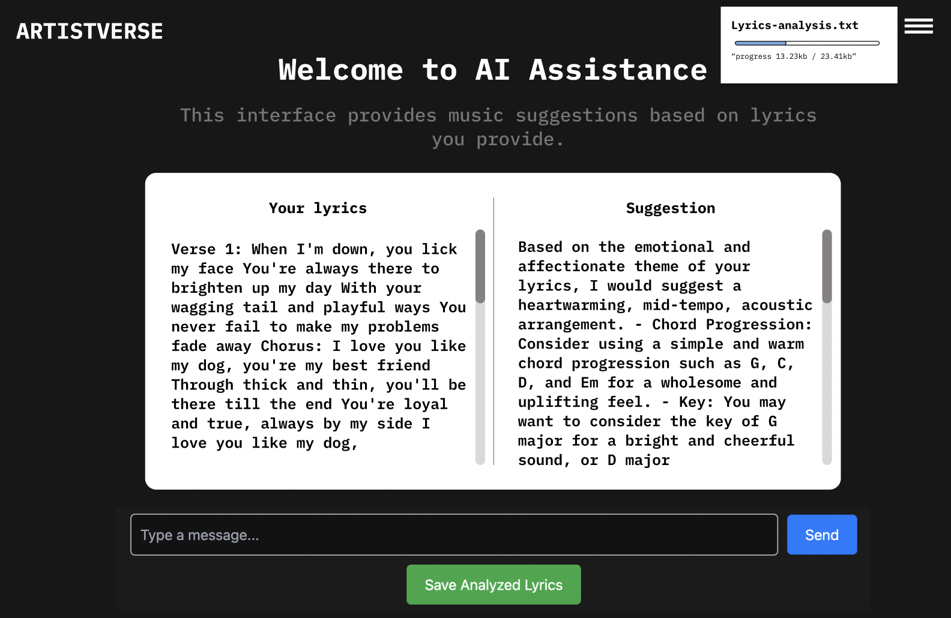
Document  Name | Artistverse-TestPlan V.3.0 | Owner | NS , WS | Page | 74
Document  Type | Test Plan | Release Date | 11/10/2024 | Print date | 11/10/2024

Test case:
No | Description | Input | Expected Result
1 | Save analyzed lyricsto local storage | None | Lyrics saved as a .txtfile on the local  computer.

Document  Name | Artistverse-TestPlan V.3.0 | Owner | NS , WS | Page | 75
Document  Type | Test Plan | Release Date | 11/10/2024 | Print date | 11/10/2024

STC-18: No Internet Connection Handling
Description: This test verifies that the system displays an error message when there isno internet connection during analysis or saving.
Prepared Data: None
Test script:
1. Disconnect from the internet.
2. Input lyrics and click "Send".

3. Click "Save" to save analyzed lyrics.

4. Verify the system displays appropriate error messages.
Document  Name | Artistverse-TestPlan V.3.0 | Owner | NS , WS | Page | 76
Document  Type | Test Plan | Release Date | 11/10/2024 | Print date | 11/10/2024

Test case:
No | Description | Input | Expected Result
1 | Attempt to analyze  lyrics without  internet | [Verse 1] When youwere here before  Couldn't look you inthe eye You're just  like an angel Your  skin makes me cry  You float like a  feather In a beautifulworld I wish I was  special You're so  fuckin' special  [Chorus] But I'm a  creep, I'm a weirdoWhat the hell am I  doin' here? I don't  belong here [Verse  2] I don't care if it  hurts I wanna have  control I want a  perfect body I wanta perfect soul I wantyou to notice WhenI'm not around  You're so fuckin'  special I wish I wasspecial [Chorus] ButI'm a creep, I'm a  weirdo What the hellam I doin' here? I  don't belong here  Oh-oh, oh-oh | Error message: "Nointernet connection."
2 | Attempt to save  analyzed lyrics  without internet | None | Error message: "Nointernet connection."

Document  Name | Artistverse-TestPlan V.3.0 | Owner | NS , WS | Page | 77
Document  Type | Test Plan | Release Date | 11/10/2024 | Print date | 11/10/2024

Appendix A
Appendix: Spotify_track
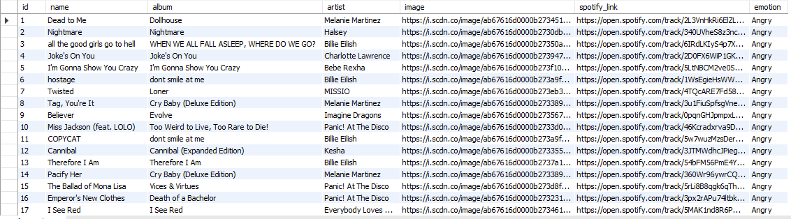
Document  Name | Artistverse-TestPlan V.3.0 | Owner | NS , WS | Page | 78
Document  Type | Test Plan | Release Date | 11/10/2024 | Print date | 11/10/2024

